
jclhk

A study of Digital Marketing Customer Experiences in E- Channel Retail system in the world,

A Meta-analysis of E –Digital Marketing perspective

Your Name, Designation and Email address

Abstract

In the present digital business scenario, companies are focusing on Omni Channel Retail phenomenon to offer a seamless experience to their customers for achieving competitive advantages at the market space. Due to the involvement of digital technologies like Artificial Intelligence and multi-channel business models, businesses had been adopting Omni Channel Retail business models as a part of digital transformation strategy to offer convenience and enrich services to customers during their journey with respective service providers. This paper is an attempt to provide an insight to Omni Channel Retailers to delight their customers using the generated acumen. A Systematic Literature Review methodology had been adopted for analyzing the extracted articles selected from Web of Science database for final review and analysis. 42 articles published in 14 reputed journals were selected for VOSviewer and Web of Science analytics and future research avenues were proposed to assist academics and practitioners.

Keywords: Customer experience, E- Marketing, Retailing, Systematic Literature Review,

1. Introduction
Omni-channel retail is not just an integration of channels but it further provides a platform for customer engagement and new ways of interaction. Retailers can easily share customer service related information across the channels (Beck & Rygl, 2015).The advancement of technology and digitalization is liable for interchangeable and seamless customer experience through Omni-channel retail. Therefore, the lines between the various channels specifically in retailing has become blur and this trend is not limited to big businesses only (Brynjolfsson et al., 2013; Trenz, 2015). Due to availability of various channels customers expects consistent and customized services which lead to enhanced brand experience (Picot-Coupey et al., 2016). Increasing usage of internet and social media has completely transformed consumer behaviour such as show rooming and web-rooming (Mosquera et al., 2017).
Omni-channel management is the integrated management of all the accessible channels and customer touch-points envisioned to enhance the customer involvement and enactment through channels (Verhoef et al., 2015).In the High tech business environment concept of retailing is continuously developing with the help of emerging communication channels and new customer touch points which further enhance customer experience. The ever demanding customers’ keeps on pressing the brands to offer better shopping experience which in turn is posing challenge to the established brand retailers. Therefore, it can be predicted that Omni channel management is going to be challenging task for the brands in times to come. Explosion of mobile technologies topped with micro communication through social media channels has rewritten the customer expectations. Showrooming, web-rooming etc. are latest behavioral changes emerged as a result of constant close customer communication.
In a nutshell, in an Omni-Channel setting, customers are getting the chance to associate with various online and offline channels across their customer journey (Ostrom et al., 2015). The limitations in the existing studies are not lacking of information but the proper analysis of the study is missing from customer relationship and service point of view. There is a need to explore the existing theories and concepts to understand the importance of Omni-channel retail in customer relationship and services context as the “Omni-channel retail” concept is relatively a new research area and hence, very limited research works have been done so far. As per review of existing studies, no review paper has been investigated Omni-channel retail and customer experience with VOSviewer software and Web of Science analytics. The present study is an attempt to bridge the gap to the existing body of knowledge on the studies related to customer experience in Omni Channel Retailing. In this paper, we seek to answer the specified Research Questions (RQ) as stated:
RQ1. What is the state of research and general publication trends on Omni Channel Retail in customer experience related studies?
RQ2. What are the foundational literature on Omni Channel Retail in customer experience related studies?
RQ3. What are future research themes on Omni Channel Retail in customer experience related studies?

For addressing the above stated RQ, the research objectives were: i) To offer research insight through extraction and review of articles using Systematic Literature Review approach. ii) To midpoint on research and general publication trends, foundational literature and future research avenue on Omni Channel Retailing studies. A Systematic Literature Review methodology was used by the researcher using three-fold approach to address the stated research questions. Firstly, a descriptive analysis related to latest developments in the field of Omni-channel Retail was conducted based on the number of papers distribution by year, journal sources, citations and country. Articles were selected from Web of Science database using keywords such as “Retail”, “Omni Channel retail”, “Customer Experience in Omni channel Retail”. The paper presents a detailed discussion of prevailing theories and already existing literature. Further the further prospects for Omni Channel retail in the modern retail environment is conferred upon. The paper concluded and stressed the importance of strong omni channel retail strategies for the brands to succeed. Literature review shows that there is a very little consensus on the management of Omni channel retail. This inspired the researcher to present at clear picture of what omni channel management stands and its present position in modern retailing. The paper proposes to contribute to the body on knowledge in following ways. Firstly it removes the clutter created around Omni channel retail by providing clarity among the concepts of multi-channel, omni channel and cross channels. Secondly it gives an overall picture of customer shopping experience related to omni channel marketing. Thirdly it opens opportunity for future research in field of omni channel retail strategies. Fourthly it offers in-depth discussion on the theories related to the topic and realistic implications. The phenomenon is extensively explored for any probable question on omni channel retail. These unveiling of facts will help retailers in the field to develop better understanding on the subject and demand of time to engage more effectively in the process to deliver better customer experience.

2. Methodology
In this second section of the research study, we have explained the methodology adopted and implemented to search, select and analyze articles as per the research theme. The selected research articles had been analyzed using three-stage process to discover the gap from existing literature (Tranfield et al., 2003). In this methodology, we followed planning, executing, and reporting, which has been adopted from Denyer and Tranfield (2009).We used this methodology as it is very useful method to uncover a wide range of related journals and research areas. There are many approaches to literature review and systematic reviews could be approached in myriad ways (Paul & Criado, 2020). Systematic Literature Review (SLR) assist in pinpointing relevant articles, selecting and judgmentally reviewing it to uncover the answer for the framed research questions by following an evidently demarcated procedure or search strategies and even the search criteria i.e. “Inclusion” as well as “Exclusion” were clearly specified in advance of the review of articles through the selection of single or multiple databases etc. within known time-period. The researchers can search articles by search key terms, search strategies (e.g. document types, publication names, journal names, research areas, inclusion/exclusion criteria etc.) to get the most suitable articles as per the research theme (Dewey, A. & Drahota, A. 2016). Hence, considering all the above specified characteristics of Systematic Literature Review methodology, the researchers had selected it to investigate existing studies related to Omni Channel Retail and customer experience.

2.1 Planning
To Conduct SLR (Systematic Literature Review) first we had planned to identify the related keywords. Omni Channel Retail and customer experience were not yet well recognized. As a result, before the formal searching, we read a variation of related articles to identify the keywords. Before the prior reading, we had observed that subsequent keywords were repeatedly present in Omni Channel related studies. The article strictly focused on Omni Channel Retail and its relationship with customer experience. “Omni-channel retail OR Omni Channel Retail”, “customer experience” OR “consumer experience”, “customer service” OR “consumer service”, “customer preference” OR “consumer preference”. As the focus of this study was on “Omni-channel retail and customer experience”, after finalizing the search keywords/terms, we further adopted “Executing” process. The time period for articles’ extraction was from 2000 to 2021(15th Feb, 2021).

2.2 Executing
In the “Executing” process, the researchers had followed two staged procedures namely, 1. Articles’ extraction and 2. Citation report preparation. In the first stage for articles’ extraction, three steps were used to search and select articles (See Figure 1 and Table 1). The first step which we followed was to conduct the keywords searching for obtaining the target articles for review based on Web of Science analytics using search keywords and was done by selecting “Topic” as searchable field. Our initial search result had shown 123 articles related to search keywords. To make sure that displayed articles as the search result could be closely related to the research theme “Investigating Customer Experiences in Omni Channel”, we planned to use inclusion and exclusion criteria. As second step, we used inclusion criteria as: Document type-Articles and Language-English and found 91 articles.

Database
Web of Science

Step 1
In step one, using search keywords stated in Table 1, articles’ extraction was done by selecting “Topic” as searchable field and abstract and 123 articles were found as search results.

Step 2
In step two, Inclusion Criteria, as stated in Table 1, was used and 91 articles were identified.

Step 3
In step three, Exclusion Criteria, as stated in Table 1, was used and finally 58 articles were shown and finally 42 articles were selected for final review.

Figure 1. Articles search and selection procedure using three steps.
Table 1. Articles extraction strategy along with steps.
Articles’ extraction from  Web of Science  Database  using three steps | Step 1  (Omni channel retail* OR Omni-channel retail*)  AND  (Customer experience OR Consumer experience OR Customer service OR Consumer service OR Customer preference OR Consumer preference) | Step 2  (Omni channel retail* OR Omni-channel retail*)  AND  (Customer experience OR Consumer experience OR Customer service OR Consumer service OR Customer preference OR Consumer preference) | Step 3  (Omni channel retail* OR Omni-channel retail*)  AND  (Customer experience OR Consumer experience OR Customer service OR Consumer service OR Customer preference OR Consumer preference)
Inclusion/  Exclusion Criteria | Using only keywords | Inclusion Criteria:  Document type-Articles  Language- English | Exclusion Criteria:  Articles other than Q1 category were excluded.
Search results | 123 | 91 | 42
Total number of articles displayed as search results |  |  | 123
Total number of articles excluded |  |  | 81
Total number of articles selected for final review |  |  | 42

In the third step, we used exclusion criteria as: Journals other than Q1 category, were excluded and we found 58 articles and after executing manual reading and checking to filter out irrelevant articles, we got 42 articles as our final selection for review (See Table 2) from 14 journals (See Table 2).
Table 2. List of selected Journals for final review.
S. No. | List of Journals as final selection | Total number of articles
1 | International Journal of Retail & Distribution Management | 10
2 | International Journal of Physical Distribution & Logistics Management | 7
3 | Journal of Retailing and Consumer Services | 5
4 | International Journal of Production Economics | 4
5 | International Journal of Electronic Commerce | 3
6 | European Journal of Operational Research | 3
7 | International Journal of Production Research | 2
8 | Journal of Business Research | 2
9 | Journal of Business Research | 1
10 | California Management Review | 1
11 | Decision Sciences | 1
12 | Industrial Marketing Management | 1
13 | Journal of Services Marketing | 1
14 | Production and Operations Management | 1
Total |  | 42

We used the software “VOSviewer” and Web of Science analytics to analyze the selected articles to reveal publications’ distribution by research areas, years, journals, publications, countries, keywords occurrence, authors’ keywords occurrence, etc. In the second stage of “Executing” phase, for citation report preparation, Web of Science analytics was employed (See Table 3).

2.3 Reporting

For the reporting process, we had conducted analysis of searching result in further section. Search results and discussions are also presented through analysis done through Web of Science analytics and VOSviewer.

3. Literature and Theory

3.1 Overview
Digitalization had changed the way retail industry use to operate in the market space and customer-retailer interface was complemented by this digital transformation as a process to drive businesses by enriching overall customer experiences. However, the traditional ways of customer-retailer interactions were being replaced by innovative digital exchange platforms such as mobile devices, web-based meeting platforms, or even computer based interface which had given birth to a new phenomenon i.e. “Omni Channel Retail” (Jocevski et al., 2019). Keeping the changing needs of the customers in mind, now it had imperative for the businesses to adopt Omni Channel approach for developing competitive advantages for excelling in their respective domains. The theories related to this phenomenon had been discussed in this section of the article.

3.2 Omni Channel Retail or Omni Channel Retailing
Omni Chanel Retail had been considered as a mature “Phenomenon” and customer inclination towards the use of online retail channels drove the fire of Omni Channel concept through delivering a memorable experiences to the shopper under various retail-setups. This phenomenon had integrated various systems in organizations which was used to operate as independent process in the earlier multi-channel retail formats, for instance product returns were integrated with MIS, inventory management system and even performance evaluation as a one whole unit, making Omni Channel operation more complex (Bernon et al., 2016). However, the advent of technology in retail sector in the form of artificial intelligence, robotics, block chain, augmented reality, and virtual reality and so on was noticed as a 360 degree transformation in the retail perspectives. With all the features that Omni Channel Retailing bring in, there were some inherent challenges faced by firms. Many small retail outlets and even some big firms were finding it difficult to fit in the complex retail environment which was created by Omni Channel Retail (Cai & Lo, 2020).
The contemporary online stores started pick up centers for their local customers whereas brick and mortar retailers forayed into online selling to expand their reach. The modern retail environment compelled the collaboration of both online and physical retail channels to provide flawless shopping experience to their customers. This emergence of new era of retailing had posed diverse challenges not only to practitioners but also to the academics in finding innovative ideas to implement Omni Channel Retailing for harvesting its full potential in their different endeavors. Various UPI services allowing payments through mobile phones had emerged like anything, this cross channel digitalization was not going to stop at any time rather it had set to spread and set the new heights for the retail industry. The industry would emerge from single channel to cross channel and finally to Omni Channel (Liao et al., 2020).

3.3 Omni Channel Retail and Customer Services
Presently customers were using various channels and touch points to have good brand experiences as they expect retailers to offer continuous, constant and tailored services (Picot-Coupey et al., 2016). Further researches on the stated themes namely: Facilitating consumer in achieving best Omni Channel experience, How Improvement in Channel service quality can lead to customer loyalty towards the channel, and Making Service quality blueprint for smart city etc. were recommended for future studies. Although, adopting Omni Channel initiatives were difficult and challenging to manage businesses (Hure et al., 2017). Additionally, other research in diverse industries had enhanced insights on how Omni Channels would be utilized by retailers to fulfill consumer expectations through adopting integrated decision making approach. Decisions like the location of godown, stock, transportation facility, timely delivery, capacity management etc. which were crucial for smooth running of their business should be given utmost importance (Saghiri et al., 2017).
Online and offline consumers were considered different, in the retail industry. Online consumers were well informed about availability of various products across retail platforms which further made it easier for them to have one to one comparison of products as well as services. In such a situation, timely delivery of product, product warranty, making the product available, cheap or free delivery became all the more important. All these logistic issues demanded more attention of retailers. But the importance of these issues were still questionable. Previous researches related to logistics of retail industry had discussed about the key factors responsible for generating customer satisfaction, but it sought to be explored in more detail (Daugherty et al., 2019). In the global business competitive environment, it had become vital for firms to integrate their business processes by adopting different retail channels, stages and digital platforms to amplify their reach to target customers (Bijmolt et al., 2021). Customers sought to get answer for their questions from service providers related to various aspects of service delivery. More specifically, the issues related to service delivery of customers’ purchased products in the way which was convenient and timely to them (Daugherty et al., 2019).
Omni Channel customers gave more weightage to timely delivery when it came to customer satisfaction, which further led to create brand loyalty. However, it was evident that retails had to allocate more time and resources towards logistic arrangements to achieve higher level of customer satisfaction (Murfield et al., 2017). Customers who had been getting more and more customized services as per their convenience as retailers were supposed to focus on timely and safe service delivery. Though, customization of products and flexibility of delivery had never been as important for retailers as it took a mainstream approach in Omni Channel Retails’ environment and had further enhanced the levels of customer satisfaction with retailers (Giannikas & McFarlane, 2021). Additionally, consumers had been preferring “Buying Online and Pick-in Store” i.e. (BOPS) which further created a win-win situations for both retailers and customers. Simultaneously, orders received online were being fulfilled through conventional retail stores. Hence, it had become challenging for retailers to deliver and maintain the same levels of services promised to online customers in comparison to conventional retail stores where customers got instant delivery (MacCarthy et al., 2019).

3.4. Omni Channel Retail and Customer Preferences
A smooth Omni Channel working sought to demand proper synchronization of two types of channels i.e. online and offline. This led to customer value generation which in turns resulted in customer satisfaction. A satisfied customer inclined to spread a positive word of mouth among public and also generated loyalty for firms’ products with their comments, reviews and opinions about the firms. No doubt, building Omni Channel model was complicated task in itself for firms globally. Yet, the ever changing customer expectations could satisfy only by clearly understanding factors that had further defined customers’ preferences with respect to innovative retail services (Hure et al., 2017). Difference between factors responsible for choice of online or offline retail settings can be attributed to variety-seeking attitude of customers, promotional offers, and convenience etc. and it was observed that if the above factors were more important for consumers, they would prefer going physically to stores for getting feel of the product whereas, others who chose convenience preferred to shop online. Moreover, those customers who looked for peer approvals and recommendations for shopping, ease of returning the product, offers and discounts were more inclined towards buying goods online (Basu & Sondhi, 2021). Luxury brand management framework that aimed at altering the luxury environment (which was the sub-total of customers’ population mix, operating in mature as well as less mature markets, experience-seeking behavior of customers and Omni Channel retailing) were helping businesses across the globe to perform better. However, businesses had started adopting Omni Channel marketing to cater to the consumer’s requirements of constant connect with the seller at the same time fulfilling customer’s need of getting entertained during their purchase journey in cordial environment (Cavender & Kincade, 2015).
Additionally, Omni Channel Retailing was designed in a manner which effectively had used the shared data from other channels for improving the overall customer experiences towards retail services. Furthermore, it had allowed retailers to interpret meaningful information from data received from diverse channels and convert it to shape consumers’ experience. By employing latest digital technologies like robotics, Artificial Intelligence (AI), Omni Channel had been delivering better analytical results. However, AI had been effectively used for tracing consumers’ preferences and making recommendations on the basis of longitudinal data analysis with a greater level of accuracy. The current scenario demonstrated that AI had not been used to its best potential in retailing. Although, many retailers still depended on chat-bots to solve customers’ queries by suggestions or recommendations. Thus, there existed a need for further studies to explore AI in the field of Omni Channel Retail for the benefit of the retailers and customers. Additionally, Omni Channel Retail sought to perform at their best levels in diverse businesses, but in the context of logistics, delivery of products in a timeliness fashion was something that had been proven to be significant for ensuring the desired satisfaction levels of customers. Though, product return policy and its quality of service was something that had been considered important by the customers while opting for “Buy Online and Ship Direct” type of services, whereas, products available at the retail outlet was given higher priority by the customers who used to buy from online store and pick the product from designated pick-up points. However, the overall customer satisfactions had been converted into customer loyalty which was high in case of Omni-channel retail mainly because it offered a better customer experience based on service delivery (Cotarelo et al., 2021).
Furthermore, Omni Channel Retail had completely integrated the entire retail operations with the sole aim of providing better experience to customers. It was ensured that customer experience should remain awesome throughout the shopping channels unrelatedly of diverse platforms (mobile, computer, television, catalogues) used by customer for shopping purposes (Saghiri et al. 2017). Omni Channel itself expressed the importance of seamless experiences for customers, customer engagement, and fulfilling customer expectations as the key components for memorable service delivery. But, fulfilling customer expectations, responding their queries, and fulfilling customer had become very challenging in Omni Channel environment (Daugherty et al., 2019). Moreover, the distinction between online and offline retail had been broaden because of more and more usage of E-Commerce for shopping related requirements that led towards fresh expectations of customers in the context of shopping experiences. Even, while shopping online customers were affectionate of using retail websites at the time of shopping through physical stores during comparing its prices and in case of non-availability of products at the physical retail outlet, buying it from the online store was the last option for them (Peinkofer et al., 2019). Thus, the purchase decision-making can be considered as physical purchase decision making or online purchase decision making rather it’s a mix of two and this was the reason why all physical stores had been opening their retail arms and related services by adopting both through their integration (Zhang et al., 2020).

3.5 Omni Channel Retail and Customer Experiences
Omni Channel Retail had offered an opportunity to enrich the customer experiences and empowers customers to commence the buying process through their own buying techniques and styles (Lee et al. 2018). However, by integrating brick and mortal stores with the online channels became a new way the retailers had been creating and delivering value for their respective customers. Additionally, an integrated multi-channel approach emphasizing on delivering seamless customer experiences during shopping through online or offline channels i.e. Omni Channel Retailing was among the new trend (Kembro et al., 2018). Moreover, to enhance customer experiences throughout their purchase journey, Omni Channel Retailing, had been playing a vital role (Bijmolt et al., 2021). It had further provided integrated shopping experience throughout the offline as well as online channels for customers (Bernon et al., 2016). Thus, for retailers who had been understanding their customer, had empathy with them and they gave close look to their requirements as well as expectations which helped in designing and customizing services as per customers’ need. Each point at which customer interacts contributed to shape experiences. However, it should be a mechanism to make both the parties satisfied with their decisions and this was possible when the retailers were in regular communication with their customers. Additionally, the technology had made retailers’ job easier by offering numerous platforms in place to get in touch with the customer. In the contemporary business environment, point of purchase communication with the shop owners and salesman were no more relevant rather customer expectations had pushed to get services till the last mile. Though, this was possible only when logistics were properly taken care of which often had proved to be the last mile of customer purchase journey (Daugherty et al., 2019). Even, the reviewers had become hybrid now as they were not only assessing online satisfaction of the customer but also were integrating customer’s physical purchase experience to asses overall customer satisfaction. However, the techno-driven retail environment had evolved the way customer used to purchase and draw experiences. Various tech innovations had changed the consumer’s outlook. Furthermore, use of Alexa, Chat bots etc. were completely new experience for the business world. Though, these tech innovations actually had laid the foundation of Omni Channel Retail (Farah & Ramadan, 2020).
Although, the chances of a customers’ buying a product online got diminished as a new physical store had been opening, but, in the long run it did not make much differences. Stores would synergize together and could start to realize that just presence of store in the nearby locality did not matter more than the actual shopping experience (Fornari et al., 2016). Moreover, the major objective of Omni Channel Retail was to provide better and memorable experiences to customer for flourishing across the channel (Mirzabeiki & Saghiri, 2020). This further demanded proper management of diverse channels and also had offered several customer touch points in turn to enhance customer experiences (Gawor & Hoberg, 2019). Though, Omni Channel had altered customer experiences with the diverse retail services’ offerings, it was clearly identified that Omni Channel Retail had to go a long way to establish itself as a widely adopted approach of retailing in the global context (Rosenmayer et al., 2018).

4. Results and Discussions
We had analyzed the selected articles by using Web of Science analytics and VOSviewer analytics considering the parameters such as research areas, publication distribution by years, countries, publishers, journals, authors, co-authors’ countries, keyword occurrences, author’s keywords occurrences etc. The citation report was also tabulated at the end of this section.

4.1 Publications’ distribution by Research areas
Based on the Web of Science database, 42 articles had been selected and after its systematic review, key research areas identified had been demonstrated in Figure 2.
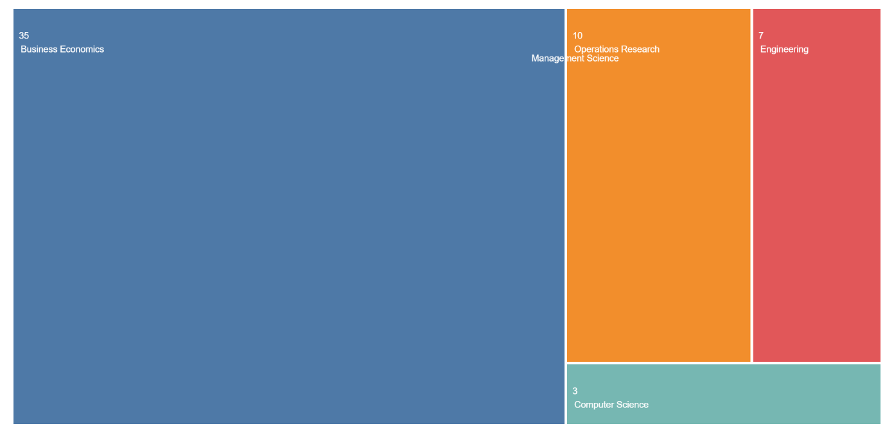
Figure 2. Publications’ distribution by Research areas.

Business Economics, Operations Research Management Science, Engineering, and Computer Science were the key research areas where Omni Channel Retail related studies had been predominantly conducted.

4.2 Publications’ distribution by Years
The “Omni Channel Retail” concept was relatively a new research area and hence, very limited research works had been done so far.
Figure 3. Publications’ distribution by Years.

Table 3. Publications’ distribution by Years.
Publication Years | Record Count | % of 42
2020 | 12 | 28.57
2019 | 10 | 23.81
2018 | 7 | 16.67
2021 | 5 | 11.90
2017 | 4 | 9.52
2016 | 3 | 7.14
2015 | 1 | 2.38

As per Web of Science analytics, top three years of publications as shown in Figure 3 and Table 3 were: 2020 (12), 2019 (10), and 2018 (7).

4.3 Publications’ distribution by Countries
Figure 4 and Table 4 demonstrated countries which had conducted research studies related to Omni Channel Retail.
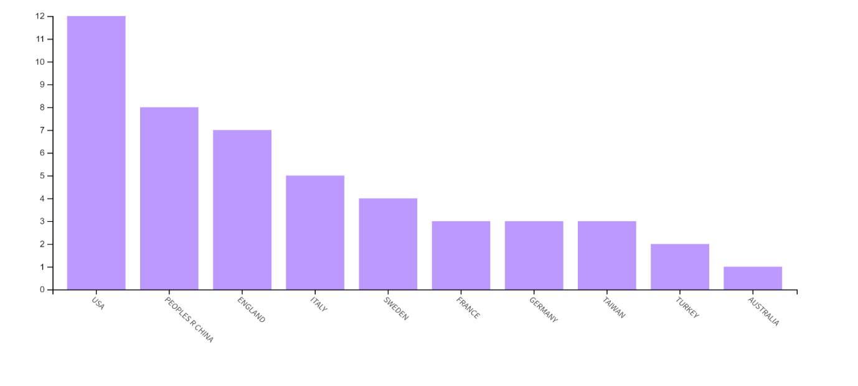
Figure 4. Publications’ distribution by Countries.
Table 4. Publications’ distribution by Countries.
Countries | Record Count | % of 42
USA | 12 | 28.57
Peoples R China | 8 | 19.05
England | 7 | 16.67
Italy | 5 | 11.91
Sweden | 4 | 9.52
France | 3 | 7.14
Germany | 3 | 7.14
Taiwan | 3 | 7.14
Turkey | 2 | 4.76
Australia | 1 | 2.38
Austria | 1 | 2.38
Lebanon | 1 | 2.38
Monaco | 1 | 2.38
Netherlands | 1 | 2.38
New Zealand | 1 | 2.38
Portugal | 1 | 2.38
Spain | 1 | 2.38

The top 5 countries were USA (12), People’s Republic of China (8), England (7), Italy (5), and Sweden (4).

4.4 Publications’ distribution by Publishers
Figure 5 and Table 5 demonstrated publishers which had published research articles related to Omni Channel Retail.

Figure 5. Publications’ distribution by Publishers.
Table 5. Publications’ distribution by Publishers.
Publishers | Record Count | % of 42
Emerald Group Publishing | 18 | 42.86
Elsevier | 16 | 38.09
Taylor & Francis | 5 | 11.91
Wiley | 2 | 4.76
Sage | 1 | 2.38
The top 3 publishers were Emerald Group Publishing (18), Elsevier (16), and Taylor & Francis (5).

4.5 Publications’ distribution by Journals
Through the Web of Science database analytics, the identified journals that had published
Figure 6. Publications’ distribution by Journals.

research articles related to Omni Channel Retail studies expressed in Figure 6 and Table 6.
Table 6. Publications’ distribution by Journals.
Publication Titles | Record Count | % of 42
International Journal of Retail Distribution Management | 10 | 23.81
International Journal of Physical Distribution Logistics Management | 7 | 16.67
Journal of Retailing and Consumer Services | 5 | 11.90
International Journal of Production Economics | 4 | 9.52
European Journal of Operational Research | 3 | 7.14
International Journal of Electronic Commerce | 3 | 7.14
Journal of Business Research | 3 | 7.14
International Journal of Production Research | 2 | 4.76
California Management Review | 1 | 2.38
Decision Sciences | 1 | 2.38
Industrial Marketing Management | 1 | 2.38
Journal of Services Marketing | 1 | 2.38
Production and Operations Management | 1 | 2.38

There were 14 journals identified in which articles related to the research themes had been published. The top 3 journals were: International Journal of Retail Distribution Management (10), International Journal of Physical Distribution Logistics Management (7), and Journal of Retailing and Consumer Services (5).

4.6 Publications’ distribution by Authors
On the basis of Web of Science database analytics, the top 5 identified authors as shown in Figure 7, who had authored research articles related to Omni Channel Retail studies were: Li G, Cheng Tce, Hure E, Jocevski M, and Liao Sh.
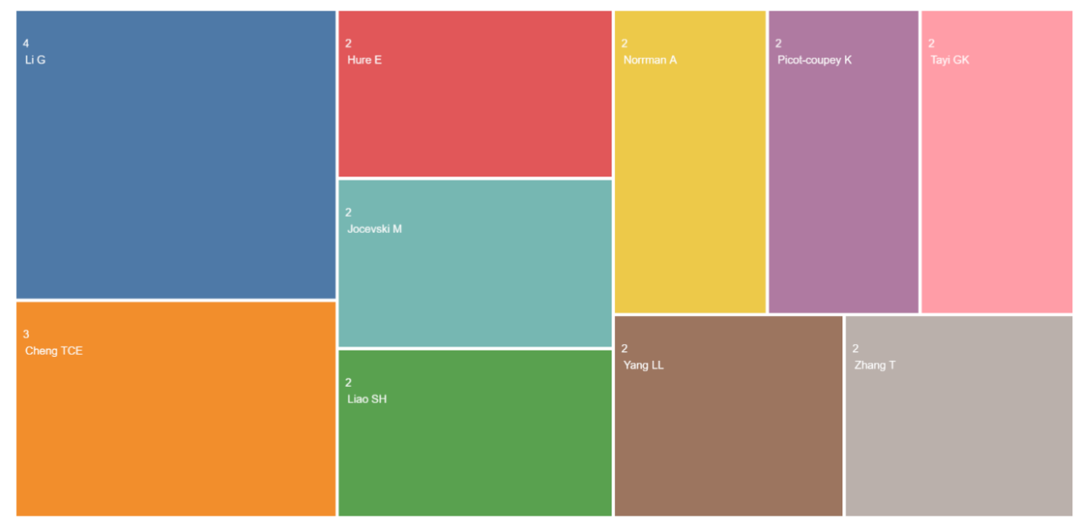
Figure 7. Publications’ distribution by Authors.

4.8 Publications’ distribution by Co-authors’ Countries
On the basis of Web of Science database analytics, the top 5 identified Co-authors’ Countries as expressed in Figure 8 were USA, People’s Republic of China, Italy, Sweden, and Germany.
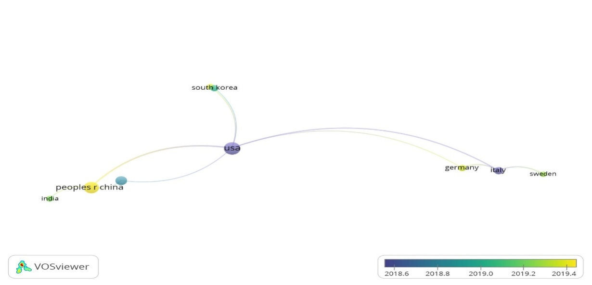
Figure 8. Publications’ distribution by Co-authors’ Countries.

4.9 Keywords Occurrences related to research theme
The 42 articles which had been selected contain numerous keywords related to this research theme and out of all the top three keywords that occurred in the selected articles based on VOSviewer analytics as expressed in Figure 9 were: Omni-Channel, Omni-Channel Retailing and E-commerce.
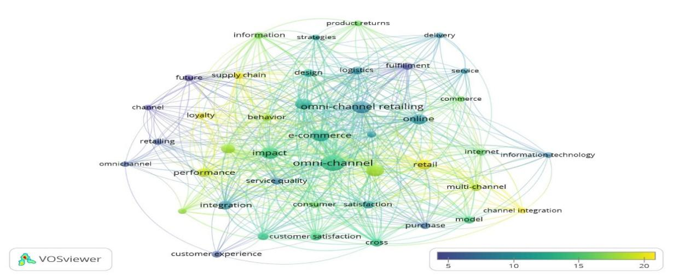
Figure 9. Publications’ distribution by Keywords occurrences related to research theme.

4.10 Authors’ Keywords Occurrences
The top six keywords that were found as “Authors’ Keywords Occurrences” in the selected 42 articles were: Omni-channel, Omni-channel retailing, E-commerce, Multi-channel, channel integration and Customer experience (See Figure 10).
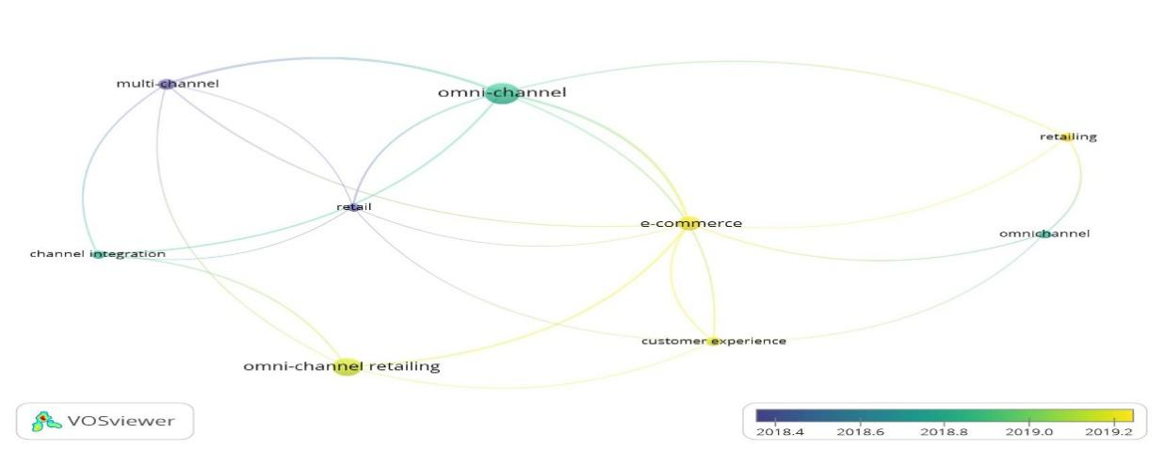

Figure 10. Publications’ distribution by Authors’ Keywords occurrences.

4.11 Citation reports of publications
The citation report for all the selected 42 articles was prepared using Web of Science analytics as shown in Figure 11 and Table 7.
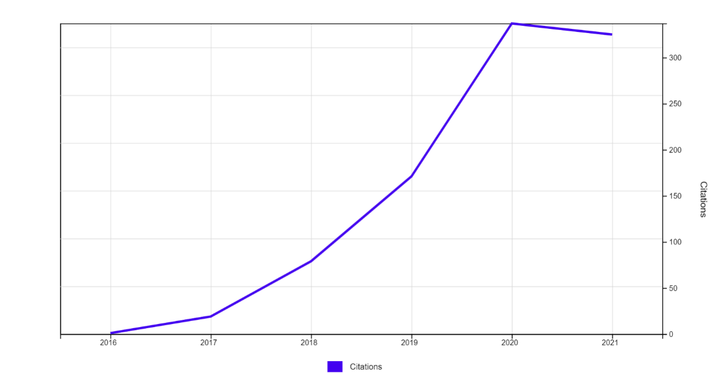
Figure 11. Citation report of publications

Table 7. Citation reports of publications.
Publication’s Title | Authors | Source Title | Publication Year | Total Citations | Average per Year | 2016 | 2017 | 2  0  1  8 | 2  0  1  9 | 2  0  2  0 | 2  0  2  1
Toward a three-dimensional framework for omni-channel | Saghiri, Soroosh; Wilding, Richard; Mena, Carlos; Bourlakis, Michael | Journal of Business Research | 2017 | 102 | 20.4 | 0 | 0 | 16 | 18 | 38 | 30
Investigating logistics service quality in omni-channel retailing | Murfield, Monique; Boone, Christopher A.; Rutner, Paige; Thomas, Rodney | International Journal of Physical Distribution & Logistics Management | 2017 | 73 | 14.6 | 0 | 0 | 7 | 22 | 21 | 23
Understanding omni-channel shopping value: A mixed-method study | Hure, Elodie; Picot-Coupey, Karine; Ackermann, Claire-Lise | Journal of Retailing and Consumer Services | 2017 | 65 | 13 | 0 | 0 | 5 | 9 | 24 | 27
Channel design to enrich customers' shopping experiences Synchronizing clicks with bricks in an omni-channel perspective - the Direct Optic case | Picot-Coupey, Karine; Hure, Elodie; Piveteau, Lauren | International Journal of Retail & Distribution Management | 2016 | 65 | 10.83 | 0 | 7 | 12 | 21 | 15 | 10
Online retail returns management Integration within an omni-channel distribution context | Bernon, Michael; Cullen, John; Gorst, Jonathan | International Journal of Physical Distribution & Logistics Management | 2016 | 61 | 10.17 | 0 | 2 | 17 | 21 | 10 | 11
Customer engagement through omnichannel retailing: The effects of channel integration quality | Lee, Zach W. Y.; Chan, Tommy K. H.; Chong, Alain Yee-Loong; Thadani, Dimple R. | Industrial Marketing Management | 2019 | 44 | 14.67 | 0 | 0 | 0 | 1 | 17 | 26
Buy online and pick up in-store: Design of the service area | Jin, Ming; Li, Gang; Cheng, T. C. E. | European Journal of Operational Research | 2018 | 44 | 11 | 0 | 0 | 2 | 10 | 21 | 11
Not all adaptive selling to omni-consumers is influential: The moderating effect of product type | Yurova, Yuliya; Rippe, Cindy B.; Weisfeld-Spolter, Suri; Sussan, Fiona; Arndt, Aaron | Journal of Retailing and Consumer Services | 2017 | 40 | 8 | 1 | 3 | 7 | 9 | 12 | 8
Configuring Retail Fulfillment Processes for Omni-Channel Customer Steering | Wollenburg, Johannes; Holzapfel, Andreas; Huebner, Alexander; Kuhn, Heinrich | International Journal of Electronic Commerce | 2018 | 37 | 9.25 | 0 | 0 | 0 | 6 | 18 | 13
Business logistics models in omni-channel: a classification framework and empirical analysis | Marchet, Gino; Melacini, Marco; Perotti, Sara; Rasini, Monica; Tappia, Elena | International Journal of Physical Distribution & Logistics Management | 2018 | 36 | 9 | 0 | 0 | 3 | 11 | 13 | 9
The new age of customer impatience An agenda for reawakening logistics customer service research | Daugherty, Patricia J.; Bolumole, Yemisi; Grawe, Scott J. | International Journal of Physical Distribution & Logistics Management | 2019 | 32 | 10.67 | 0 | 0 | 0 | 6 | 18 | 8
Build touchpoints and they will come: transitioning to omnichannel retailing | Larke, Roy; Kilgour, Mark; O'Connor, Huw | International Journal of Physical Distribution & Logistics Management | 2018 | 31 | 7.75 | 0 | 0 | 2 | 8 | 12 | 9
Adding store to web: migration and synergy effects in multi-channel retailing | Fornari, Edoardo; Fornari, Daniele; Grandi, Sebastiano; Menegatti, Mario; Hofacker, Charles F. | International Journal of Retail & Distribution Management | 2016 | 30 | 5 | 0 | 6 | 7 | 3 | 4 | 10
Customers' valuation of time and convenience in e-fulfillment | Gawor, Tobias; Hoberg, Kai | International Journal of Physical Distribution & Logistics Management | 2019 | 27 | 9 | 0 | 0 | 0 | 5 | 15 | 7
Adapting warehouse operations and design to omni-channel logistics: A literature review and research agenda | Kembro, Joakim Hans; Norrman, Andreas; Eriksson, Ebba | International Journal of Physical Distribution & Logistics Management | 2018 | 27 | 6.75 | 0 | 0 | 0 | 6 | 12 | 9
Transitions towards omni-channel retailing strategies: a business model perspective | Jocevski, Milan; Arvidsson, Niklas; Miragliotta, Giovanni; Ghezzi, Antonio; Mangiaracina, Riccardo | International Journal of Retail & Distribution Management | 2019 | 26 | 8.67 | 0 | 0 | 0 | 2 | 14 | 10
An investigation of consumers' purchase intentions towards omni-channel shopping: A qualitative exploratory study | Kazancoglu, Ipek; Aydin, Hatice | International Journal of Retail & Distribution Management | 2018 | 21 | 5.25 | 0 | 0 | 0 | 3 | 10 | 8
Omni-channel service failures and recoveries: refined typologies using Facebook complaints | Rosenmayer, Anneliese; McQuilken, Lisa; Robertson, Nichola; Ogden, Steve | Journal of Services Marketing | 2018 | 19 | 4.75 | 0 | 0 | 0 | 1 | 12 | 6
Investigating the influential factors of return channel loyalty in omni-channel retailing | Xu, Xun; Jackson, Jonathan E. | International Journal of Production Economics | 2019 | 17 | 5.67 | 0 | 0 | 0 | 1 | 6 | 10
Best Performance Frontiers for Buy-Online-Pickup-in-Store order fulfilment | MacCarthy, Bart L.; Zhang, Lina; Muyldermans, Luc | International Journal of Production Economics | 2019 | 16 | 5.33 | 0 | 0 | 0 | 1 | 9 | 6
Omni-channel retailing: Do offline retailers benefit from online reviews? | Li, Yiming; Li, Gang; Tayi, Giri Kumar; Cheng, T. C. E. | International Journal of Production Economics | 2019 | 15 | 5 | 0 | 0 | 0 | 1 | 5 | 9
Omni-channel management in the new retailing era: A systematic review and future research agenda | Cai, Ya-Jun; Lo, Chris K. Y. | International Journal of Production Economics | 2020 | 14 | 7 | 0 | 0 | 0 | 0 | 3 | 11
Inroad into omni-channel retailing: Physical showroom deployment of an online retailer | Li, Gang; Zhang, Tao; Tayi, Giri Kumar | European Journal of Operational Research | 2020 | 12 | 6 | 0 | 0 | 0 | 0 | 3 | 9
The Value of Buy-Online-and-Pickup-in-Store in Omni-Channel: Evidence from Customer Usage Data | Song, Peijian; Wang, Quansheng; Liu, Hefu; Li, Qi | Production and Operations Management | 2020 | 8 | 4 | 0 | 0 | 0 | 0 | 4 | 4
Assessing the impact of drop-shipping fulfilment operations on the upstream supply chain | Peinkofer, Simone T.; Esper, Terry L.; Smith, Ronn J.; Williams, Brent D. | International Journal of Production Research | 2019 | 8 | 2.67 | 0 | 0 | 0 | 2 | 3 | 3
Exploring trends, implications and challenges for logistics information systems in omni-channels: Swedish retailers' perception | Kembro, Joakim; Norrman, Andreas | International Journal of Retail & Distribution Management | 2019 | 8 | 2.67 | 0 | 0 | 0 | 1 | 4 | 3
Consumer Inter-Product Showrooming and Information Service Provision in an Omni-Channel Supply Chain | Zhang, Tao; Li, Gang; Cheng, T. C. Edwin; Shum, Stephen | Decision Sciences | 2020 | 7 | 3.5 | 0 | 0 | 0 | 0 | 2 | 5
Omni-channel capability and customer satisfaction: mediating roles of flexibility and operational logistics service quality | Sorkun, Metehan Feridun; Yumurtaci Huseyinoglu, Isik Ozge; Boruhan, Gulmus | International Journal of Retail & Distribution Management | 2020 | 6 | 3 | 0 | 0 | 0 | 0 | 0 | 6
Viability of Amazon's driven innovations targeting shoppers' impulsiveness | Farah, Maya F.; Ramadan, Zahy B. | Journal of Retailing and Consumer Services | 2020 | 6 | 3 | 0 | 0 | 0 | 0 | 2 | 4
A luxury brand management framework built from historical review and case study analysis | Cavender, RayeCarol; Kincade, Doris H. | International Journal of Retail & Distribution Management | 2015 | 6 | 0.86 | 0 | 1 | 1 | 3 | 0 | 1
Challenges at the marketing-operations interface in omni-channel retail environments | Bijmolt, Tammo H. A.; Broekhuis, Manda; de Leeuw, Sander; Hirche, Christian; Rooderkerk, Robert P.; Sousa, Rui; Zhu, Stuart X. | Journal of Business Research | 2021 | 5 | 5 | 0 | 0 | 0 | 0 | 2 | 3
Mobile payment and online to offline retail business models | Liao, Shu-Hsien; Yang, Ling-Ling | Journal of Retailing and Consumer Services | 2020 | 5 | 2.5 | 0 | 0 | 0 | 0 | 3 | 2
From ambition to action: How to achieve integration in omni-channel? | Mirzabeiki, Vahid; Saghiri, Soroosh Sam | Journal of Business Research | 2020 | 5 | 2.5 | 0 | 0 | 0 | 0 | 2 | 3
How website browsing impacts expectations of store features | Loupiac, Philippine; Goudey, Alain | International Journal of Retail & Distribution Management | 2019 | 4 | 1.33 | 0 | 0 | 0 | 0 | 2 | 2
Reducing Competitive Research Shopping With Cross-Channel Delivery | Weber, Anja; Maier, Erik | International Journal of Electronic Commerce | 2020 | 3 | 1.5 | 0 | 0 | 0 | 0 | 1 | 2
Examining the value of flexible logistics offerings | Giannikas, Vaggelis; McFarlane, Duncan | European Journal of Operational Research | 2021 | 2 | 2 | 0 | 0 | 0 | 0 | 0 | 2
Blurring the Lines between Physical and Digital Spaces: Business Model Innovation in Retailing | Jocevski, Milan | California Management Review | 2020 | 2 | 1 | 0 | 0 | 0 | 0 | 0 | 2
A further approach in omnichannel LSQ, satisfaction and customer loyalty | Cotarelo, Mitxel; Calderon, Haydee; Fayos, Teresa | International Journal of Retail & Distribution Management | 2021 | 1 | 1 | 0 | 0 | 0 | 0 | 0 | 1
Applying transfer learning to automate annotation in an omni-channel system - a case study of a shared kitchen platform | Chiu, Ming-Chuan; Chuang, Kai-Hsiang | International Journal of Production Research | 2021 | 1 | 1 | 0 | 0 | 0 | 0 | 0 | 1
An Integrated Randomized Pricing Strategy for Omni-Channel Retailing | Wu, Jianghua; Zhao, Chenchen; Yan, Xinghao; Wang, Lifei | International Journal of Electronic Commerce | 2020 | 1 | 0.5 | 0 | 0 | 0 | 0 | 0 | 1
The end of the world as we know it? The influence of online channels on the luxury customer experience | Klaus, Philipp 'Phil' | Journal of Retailing and Consumer Services | 2020 | 0 | 0 | 0 | 0 | 0 | 0 | 0 | 0
Online versus offline: preferred retail choice for premium brand purchase | Basu, Rituparna; Sondhi, Neena | International Journal of Retail & Distribution Management | 2021 | 0 | 0 | 0 | 0 | 0 | 0 | 0 | 0
Total |  |  |  | 932 | 22.19

Mainly, articles that were selected had been published between 2015 and 2021 (Feb 15th, 2021) with 932 as articles citation sum. The number of citations was highest in the year 2020 whereas years 2016 had witnessed the lowest number of citations. The top citation years based on average citations per item per year (i.e. 22.19) were 2018, 2019, 2020 and 2021(Feb 15th, 2021) with18 as the total articles’ H-index. Based on individual article’s citation information data shown in Table 7, it was found that “Journal of Business Research” had the highest average citation value i.e. 20.40 for the article authored by Saghiri et al., (2017).

5. Avenues for Future research
The future research avenues were tabulated in Table 8 that can assist the academics and practitioners in their future endeavors on this research theme.
Table 8. Avenues for Future research.
S. No. | Research Domains | Future Research Avenues
1. | Omni Channel Retail and Management | - Channel integration and interaction can be investigated in online and offline context.  - Role of new technological disruption in Omni Channel Retail advancement should be explored.
2. | Omni Channel Retail and Customer Service | - Ways to offer better Consumer supports services should be investigated.  - Omni Channel Retail’s Service quality enhancement should be examined to improve customer loyalty.
3. | Omni Channel Retail and Customer Preference | - Changing customer preferences and behaviour in the Omni Channel Retail should be explored.
4. | Omni Channel Retail and Customer Experience | - Omni Channel Retail’s Service delivery and its relationship with customer experience needed to be explored.  - The ways to offer seamless Omni Channel Retail’s Customer experience could be investigated in detailed.
There is a need to investigate “Omni Channel Retail” as a phenomenon in diverse geographical settings, sectoral settings and organizational settings in the light of diverse themes related to Omni Channel Retail studies. The better the understandings on Omni Channel Retail, the better would be the customer experiences and more could be the value creation and delivery to the customers, which might develop organizational competitive advantages.

6. Conclusion
In this research work, we had conducted a Systematic Literature Review using Web of science database by selecting articles related to the “Customer experiences”, “Customers services” and “Customer preferences” in “Omni Channel Retail” and based on Web of Science analytics, 42 articles had been analyzed. The H-index of total articles was found to be 18 with 22.19 as Average Citations per item. The sum of the times articles cited was 932. The research was explored using multi-disciplinary approach as the Omni Channel Retail concept had been predominantly studied in a various fields such as Business, Management, and Operations Research Management Science. Moreover, using VOSviewer, it was observed that Omni Channel, Omni Channel Retailing, E-Commerce, Multi-channel, channel integration and Customer experience were the major authors’ keywords occurred in the selected analyzed articles. The academic literature had the lack of consent in context of Omni Channel related studies, and its originality and significance in today’s business scenario sought further investigation in diverse sectoral and geographical settings. The major contribution of the present study was the development and enhancement of the understanding about the Omni Channel Retail related studies that were conducted in the past two decades and the derived knowledge would assist academics and practitioners in developing acumen on this emerging phenomenon from a theoretical and practical perspectives.
References
Basu, R., & Sondhi, N. (2021). Online versus offline: preferred retail choice for premium brand purchase. International Journal of Retail & Distribution Management.
Beck, N., & Rygl, D. (2015). Categorization of multiple channel retailing in Multi-, Cross-, and Omni‐Channel Retailing for retailers and retailing. Journal of Retailing and Consumer Services, 27, 170-178.
Bernon, M., Cullen, J., & Gorst, J. (2016). Online retail returns management: Integration within an omni-channel distribution context. International Journal of Physical Distribution & Logistics Management, 46(6/7), 584-605.
Bijmolt, T. H., Broekhuis, M., De Leeuw, S., Hirche, C., Rooderkerk, R. P., Sousa, R., & Zhu, S. X. (2021). Challenges at the marketing–operations interface in omni-channel retail environments. Journal of Business Research, 122, 864-874.
Brynjolfsson, E., Hu, Y. J., & Rahman, M. S. (2013). Competing in the age of omnichannel retailing (pp. 1-7). Cambridge: MIT.
Cai, Y. J., & Lo, C. K. (2020). Omni-channel management in the new retailing era: A systematic review and future research agenda. International Journal of Production Economics, 229, 107729.
Cavender, R., & Kincade, D. H. (2015). A luxury brand management framework built from historical review and case study analysis. International Journal of Retail & Distribution Management, 43(10/11), 1083-1100.
Chiu, M. C., & Chuang, K. H. (2021). Applying transfer learning to automate annotation in an omni-channel system-a case study of a shared kitchen platform. International Journal of Production Research.
Cotarelo, M., Calderón, H., & Fayos, T. (2021). A further approach in omnichannel LSQ, satisfaction and customer loyalty. International Journal of Retail & Distribution Management, 49(8), 1133-1153.
Daugherty, P. J., Bolumole, Y., & Grawe, S. J. (2019). The new age of customer impatience: An agenda for reawakening logistics customer service research. International Journal of Physical Distribution & Logistics Management, 49(1), 4-32.
Denyer, D., & Tranfield, D. (2009). Producing a systematic review. In D. A. Buchanan & A. Bryman (Eds.), The Sage handbook of organizational research methods (pp. 671–689). Sage Publications Ltd.
Dewey, A. & Drahota, A. (2016). Introduction to systematic reviews: online learning module. Cochrane Training. https://training.cochrane.org/interactivelearning/module-1-introduction-conducting-systematic-reviews
Farah, M. F., & Ramadan, Z. B. (2020). Viability of Amazon’s driven innovations targeting shoppers’ impulsiveness. Journal of Retailing and Consumer Services, 53, 101973.
Fornari, E., Fornari, D., Grandi, S., Menegatti, M., & Hofacker, C. F. (2016). Adding store to web: migration and synergy effects in multi-channel retailing. International Journal of Retail & Distribution Management, 44(6), 658-674.
Gawor, T., & Hoberg, K. (2019). Customers’ valuation of time and convenience in e-fulfillment. International Journal of Physical Distribution & Logistics Management, 49(1), 75-98.
Giannikas, V., & McFarlane, D. (2021). Examining the value of flexible logistics offerings. European Journal of Operational Research, 290(3), 968-981.
Huré, E., Picot-Coupey, K., & Ackermann, C. L. (2017). Understanding omni-channel shopping value: A mixed-method study. Journal of Retailing and Consumer Services, 39, 314-330.
Jin, M., Li, G., & Cheng, T. C. E. (2018). Buy online and pick up in-store: Design of the service area. European Journal of Operational Research, 268(2), 613-623.
Jocevski, M. (2020). Blurring the lines between physical and digital spaces: business model innovation in retailing. California Management Review, 63(1), 99-117.
Jocevski, M., Arvidsson, N., Miragliotta, G., Ghezzi, A., & Mangiaracina, R. (2019). Transitions towards omni-channel retailing strategies: a business model perspective. International Journal of Retail & Distribution Management, 47(2), 78-93.
Kazancoglu, I., & Aydin, H. (2018). An investigation of consumers’ purchase intentions towards omni-channel shopping: A qualitative exploratory study. International Journal of Retail & Distribution Management, 46(10), 959-976.
Kembro, J. H., Norrman, A., & Eriksson, E. (2018). Adapting warehouse operations and design to omni-channel logistics: A literature review and research agenda. International Journal of Physical Distribution & Logistics Management, 48(9), 890-912.
Kembro, J., & Norrman, A. (2019). Exploring trends, implications and challenges for logistics information systems in omni-channels: Swedish retailers’ perception. International Journal of Retail & Distribution Management, 47(4), 384-411.
Klaus, P. P. (2020). The end of the world as we know it? The influence of online channels on the luxury customer experience. Journal of Retailing and Consumer Services, 57.
Larke, R., Kilgour, M., & O’Connor, H. (2018). Build touchpoints and they will come: transitioning to omnichannel retailing. International Journal of Physical Distribution & Logistics Management, 48(4), 465-483.
Lee, Z. W., Chan, T. K., Chong, A. Y. L., & Thadani, D. R. (2019). Customer engagement through omnichannel retailing: The effects of channel integration quality. Industrial Marketing Management, 77, 90-101.
Li, G., Zhang, T., & Tayi, G. K. (2020). Inroad into omni-channel retailing: Physical showroom deployment of an online retailer. European Journal of Operational Research, 283(2), 676-691.
Li, Y., Li, G., Tayi, G. K., & Cheng, T. C. E. (2019). Omni-channel retailing: Do offline retailers benefit from online reviews?. International Journal of Production Economics, 218, 43-61.
Liao, S. H., & Yang, L. L. (2020). Mobile payment and online to offline retail business models. Journal of Retailing and Consumer Services, 57, 102230.
Loupiac, P., & Goudey, A. (2019). How website browsing impacts expectations of store features. International Journal of Retail & Distribution Management, 48(1), 92-108.
MacCarthy, B. L., Zhang, L., & Muyldermans, L. (2019). Best performance frontiers for buy-online-pickup-in-store order fulfilment. International Journal of Production Economics, 211, 251-264.
Marchet, G., Melacini, M., Perotti, S., Rasini, M., & Tappia, E. (2018). Business logistics models in omni-channel: a classification framework and empirical analysis. International Journal of Physical Distribution & Logistics Management, 48(4), 439-464.
Mirzabeiki, V., & Saghiri, S. S. (2020). From ambition to action: How to achieve integration in omni-channel?. Journal of Business Research, 110, 1-11.
Mosquera, A., Pascual, C. O., & Ayensa, E. J. (2017). Understanding the customer experience in the age of omni-channel shopping. Icono14, 15(2), 5.
Murfield, M., Boone, C. A., Rutner, P., & Thomas, R. (2017). Investigating logistics service quality in omni-channel retailing. International Journal of Physical Distribution & Logistics Management, 47(4), 263-296.
Ostrom, A. L., Parasuraman, A., Bowen, D. E., Patrício, L., & Voss, C. A. (2015). Service research priorities in a rapidly changing context. Journal of Service Research, 18(2), 127-159.
Paul, J., & Criado, A. R. (2020). The art of writing literature review: What do we know and what do we need to know?. International Business Review, 29(4), 101717.
Peinkofer, S. T., Esper, T. L., Smith, R. J., & Williams, B. D. (2019). Assessing the impact of drop-shipping fulfilment operations on the upstream supply chain. International Journal of Production Research, 57(11), 3598-3621.
Picot-Coupey, K., Huré, E., & Piveteau, L. (2016). Channel design to enrich customers’ shopping experiences: synchronizing clicks with bricks in an omni-channel perspective-the Direct Optic case. International Journal of Retail & Distribution Management, 44(3).
Rosenmayer, A., McQuilken, L., Robertson, N., & Ogden, S. (2018). Omni-channel service failures and recoveries: refined typologies using Facebook complaints. Journal of Services Marketing, 32(3), 269-285.
Saghiri, S., Wilding, R., Mena, C., & Bourlakis, M. (2017). Toward a three-dimensional framework for omni-channel. Journal of Business Research, 77, 53-67.
Song, P., Wang, Q., Liu, H., & Li, Q. (2020). The value of buy‐online‐and‐pickup‐in‐store in omni‐channel: evidence from customer usage data. Production and Operations Management, 29(4), 995-1010.
Sorkun, M. F., Hüseyinoğlu, I. Ö. Y., & Börühan, G. (2020). Omni-channel capability and customer satisfaction: mediating roles of flexibility and operational logistics service quality. International Journal of Retail & Distribution Management, 48(6), 629-648.
Tranfield, D., Denyer, D., & Smart, P. (2003). Towards a methodology for developing evidence‐informed management knowledge by means of systematic review. British Journal of Management, 14(3), 207-222.
Trenz, M. (2015). The blurring line between electronic and physical channels: Reconceptualising multichannel commerce, 184.
Verhoef, P. C., Kannan, P. K., & Inman, J. J. (2015). From multi-channel retailing to omni-channel retailing: introduction to the special issue on multi-channel retailing. Journal of Retailing, 91(2), 174-181.
Weber, A., & Maier, E. (2020). Reducing competitive research shopping with cross-channel delivery. International Journal of Electronic Commerce, 24(1), 78-106.
Wollenburg, J., Holzapfel, A., Hübner, A., & Kuhn, H. (2018). Configuring retail fulfillment processes for omni-channel customer steering. International Journal of Electronic Commerce, 22(4), 540-575.
Wu, J., Zhao, C., Yan, X., & Wang, L. (2020). An integrated randomized pricing strategy for omni-channel retailing. International Journal of Electronic Commerce, 24(3), 391-418.
Xu, X., & Jackson, J. E. (2019). Investigating the influential factors of return channel loyalty in omni-channel retailing. International Journal of Production Economics, 216, 118-132.
Yurova, Y., Rippé, C. B., Weisfeld-Spolter, S., Sussan, F., & Arndt, A. (2017). Not all adaptive selling to omni-consumers is influential: The moderating effect of product type. Journal of Retailing and Consumer Services, 34, 271-277.
Zhang, T., Li, G., Cheng, T. E., & Shum, S. (2020). Consumer Inter‐Product Showrooming and Information Service Provision in an Omni‐Channel Supply Chain. Decision Sciences, 51(5), 1232-1264.

