The Cosmic Tree Symbol in Northeast Asian Shamanic Culture: A Visual Communication Study from the Perspective of Ecosemiotics

Jianfei Shi¹, Meiyuan Yun^{2,}*
¹College of Fine Arts, Beihua University, Jilin 132013, China
E-mail address: shijianfei@vip.163.com
²College of Fine Arts, Beihua University, Jilin 132013, China
E-mail address: 343204463@qq.com
*Corresponding author

Abstract
This study explores the cosmic tree symbol in Northeast Asian shamanic culture through an ecosemiotic and visual communication lens, proposing a four-dimensional model: Nature→Symbol→Visual→Communication. It examines how the ecological characteristics of native tree species are symbolized and integrated into cultural practices. Using fieldwork and multi-source data, the research analyzes the cosmic tree’s ecological prototypes and symbolic mappings in shamanic rituals. It applies Charles S. Peirce’s triadic sign model to deconstruct its semiotic structure, focusing on index, icon, and interpretant. Using Kress and Van Leeuwen’s visual grammar, the study investigates the tree’s representation in traditional embroidery, sculpture, and digital design. Cross-cultural comparisons reveal both differences and shared innovations between the shamanic tree and other cultural representations, offering insights into sustainable communication strategies for preserving cultural heritage through multimodal design.
Keywords
Northeast Asian Shamanic Culture, Cosmic Tree Symbol, Ecosemiotics, Visual Communication, Cross-Cultural Transmission
1. Introduction
1.1 Research Background
Shamanism, as a primordial religious system originating in prehistoric times, stands among the oldest and most enduring spiritual traditions in human history. At its core lies the belief in animism the notion that every element of the natural world, whether trees, rivers, or animals, possesses a distinct spiritual essence. This animistic worldview not only shaped early cosmological understanding but also provided a foundational framework for articulating the human–nature relationship. In the Northeast Asian region (which includes Northeast China, Mongolia, the Korean Peninsula, and the Russian Far East, Fig. 1) this cultural paradigm is particularly prominent within the shamanic traditions of Tungusic, Mongolic, and other indigenous groups.
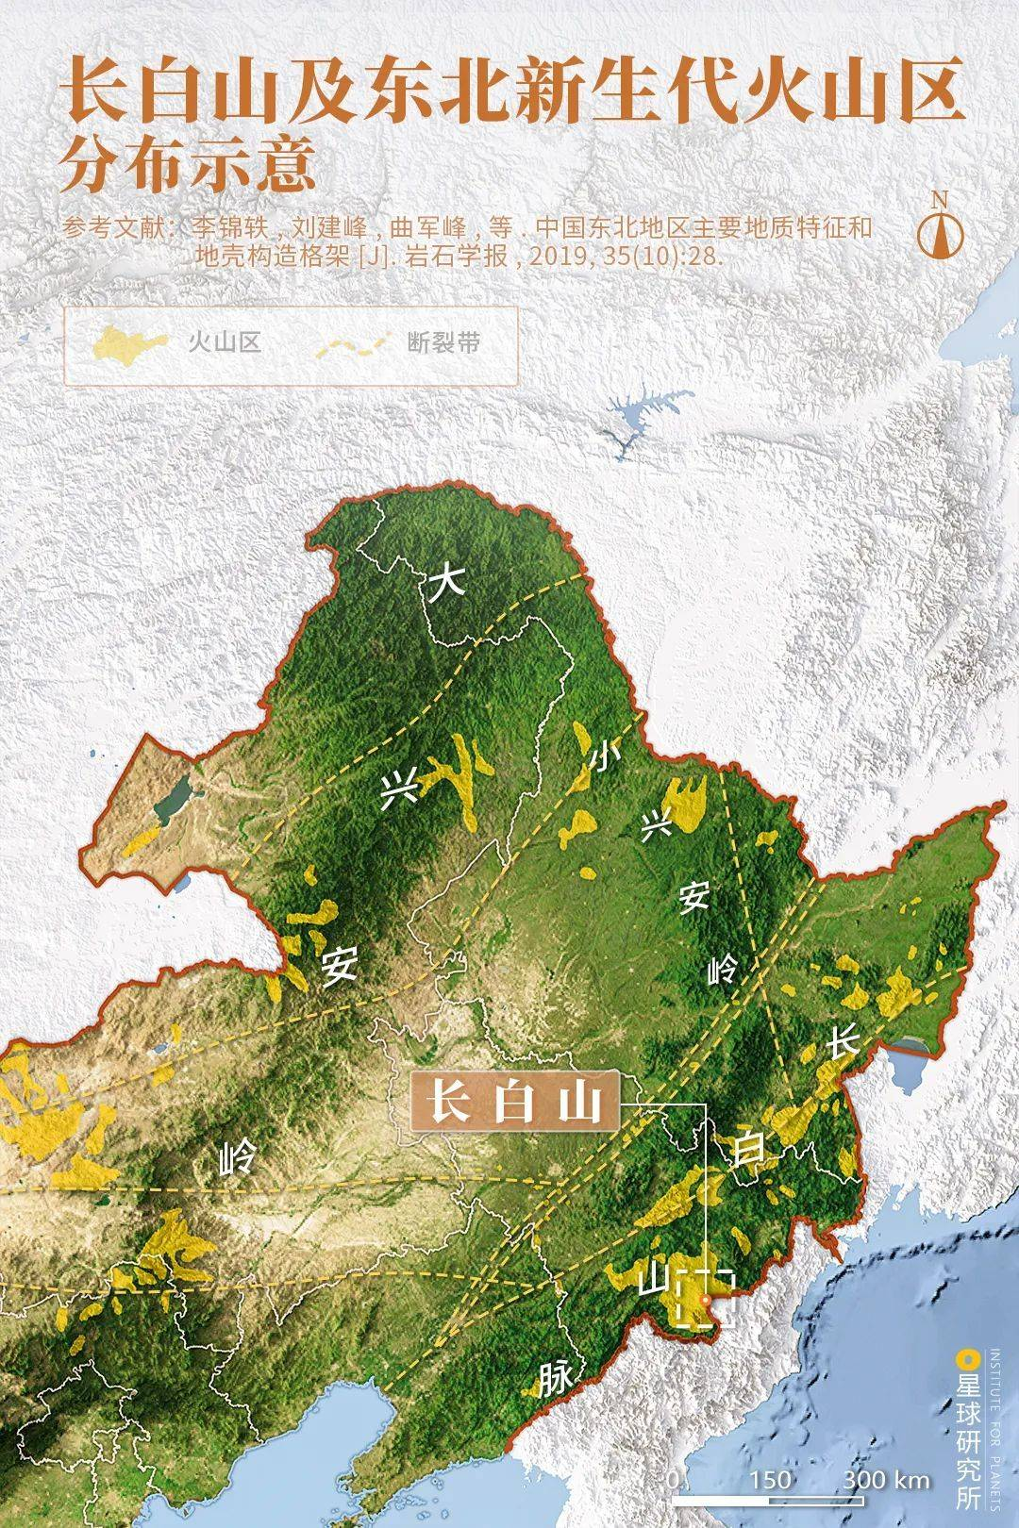
Figure 1: Forest Coverage in Northeast China
Source: 星球研究所
The cosmological framework of shamanic culture positions the "tree" as a central element in both ritual practice and visual symbolism, establishing a vertical axis that connects the celestial, terrestrial, and human realms. This symbolic form commonly referred to as the Cosmic Tree or Axis Mundi serves simultaneously as a concrete representation of ecological reality (e.g., Pinus sylvetriformis, Spruce) and as a visualized expression of spiritual belief. While existing scholarship has extensively explored the religious functions of the shamanic tree (Eliade, 1964) or its symbolic narratives within singular cultural contexts, it has largely overlooked the dynamic interplay between its ecological foundations and its visual grammar. Against the backdrop of emerging ecosemiotic theory and multimodal visual communication studies, there is a pressing need to deconstruct the symbolic logic of the shamanic tree from an interdisciplinary perspective specifically, to examine how natural properties are transfigured through artistic practice into enduring cultural mythologies.
1.2 Research Objective
This study aims to investigate the transformation of the shamanic tree symbol from ecological prototype to cultural emblem within the shamanic traditions of Northeast China, employing an ecosemiotic framework. It further applies visual communication theory to uncover how this symbol adapts to and functions within cross-cultural modes of transmission.
1.3 Research Questions
This research addresses three core questions:
(1) How do the ecological characteristics of tree species native to Northeast China (such as the height of the Pinus sylvetriformis and the evergreen quality of the Spruce) inform the form and meaning of the cosmic tree symbol?
(2) How does its visual grammar (specifically axial symmetry and color coding) mediate and express cosmological narratives?
(3) In what ways can traditional symbols be semantically reinterpreted through contemporary design for global cultural contexts?
1.4 Significance of the Research
At the theoretical level, by centering on the ecological and cultural specificity of Northeast China, this study constructs a four-dimensional analytical model “Nature→Symbol→Visual→Communication” which offers a methodological innovation for the study of regional cultural symbolism. At the practical level, by tracing the contemporary transformations of the shamanic tree symbol, the research proposes new paradigms for the living transmission and global articulation of Northeast Asian cultural heritage, aligning with UNESCO’s dual imperatives of cultural diversity and ecological sustainability.
2. Theoretical Framework
2.1 An Ecosemiotic Perspective
Ecosemiotics, situated at the intersection of cultural semiotics and the environmental humanities, underscores the co-creative dynamics between natural systems and sign systems. Centering on the bidirectional exchange of meaning between nature and culture, ecosemiotics posits that ecological properties become integral to cultural construction through processes of symbolization. Drawing on Peirce’s triadic model of the sign, this study deconstructs the shamanic tree symbol into its representamen, object, and interpretant. Within this framework, the material characteristics of tree species are encoded into cultural symbols via shamanic rituals and artistic practices, thereby enacting a “Nature → Sign” transformation. For instance, the vertical stature of the Changbai pine is imbued with the religious significance of “linking the three realms,” while its ecological symbiosis with avian species is reconceptualized as a visual metaphor for “soul migration.” By incorporating an ecosemiotic lens, this research gains both a methodological tool for dissecting the mechanisms of symbol formation and a means to illuminate the active role of natural landscapes in cultural memory.
Table 1. Deconstruction of the Shamanic Tree Symbol
Representamen | Object | Interpretant
Vertical morphology of the Changbai pine | Temperate forest ecosystem | Symbol of the cosmic axis
Source: Prepared by the author.
2.2 Visual Communication Theory
The study of visual communication has evolved from functional transmission models to multimodal analytical paradigms. Kress and Van Leeuwen’s Visual Grammar framework integrates elements such as composition, modality and information value into the semiotic domain, emphasizing that images possess both syntactic structure and rhetorical function. Within this paradigm, the visual is not merely a passive means of display but an active system for constructing cultural meaning. In the case of the World Tree, its visual manifestations—axial symmetry, vertical ascending linear structures, symbolic color schemes and decorative motifs all serve distinct visual-grammar functions and interlock with the action sequences and spatial arrangements of shamanic rituals to form a compound visual embodied–cultural nexus. Moreover, visual communication theory offers a multimodal fusion perspective, facilitating an understanding of how traditional imagery may be deconstructed and reconstituted within digital contexts.
2.3 Theoretical Integration
To systematically elucidate the World Tree symbol’s dual ecological and communicative properties, this study proposes a four-dimensional analytical pathway of “Nature→Sign→Visual→Communication” (Fig. 5). First, drawing on ecosemiotics, the tree is positioned as a nexus between natural species and cultural imagery, allowing for the identification of its ecological-semantic traits and mechanisms of symbol generation. Second, through the lens of visual communication theory, the compositional logic, color encoding and visual grammar of World Tree depictions are dissected. Finally, these processes are situated within a cross-cultural communication framework to explore how the symbol’s formal variations and cultural adaptability manifest in contemporary visual reproduction. This integrative model not only bridges natural ecology and cultural expression but also provides the theoretical underpinning for understanding the dynamic dissemination of ecological symbols in visual practice transcending traditional disciplinary boundaries by unifying the symbol’s ecological foundations with its visual form throughout the communication process.
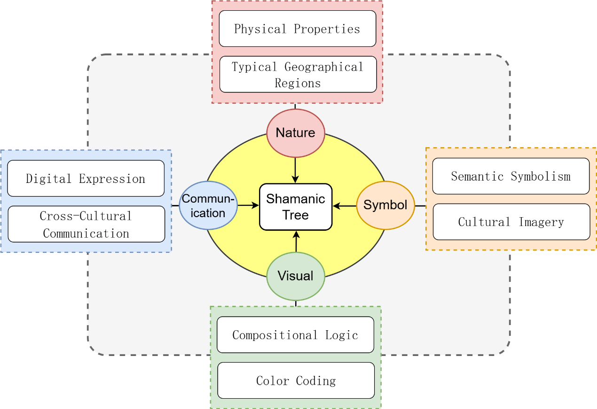
Figure 5: Theoretical Framework
Source: Prepared by the author.

3. Research Methods
3.1 Fieldwork and Data Collection
This study’s fieldwork focuses on Shamanic cultural vestiges in Northeast China, with particular attention to ritual paraphernalia, folk narratives, and living specimens associated with the World Tree symbol. Given the region’s high forest cover (Fig. 6), field sites were selected in Yanbian Prefecture (Jilin Province), Hezhe communities in Heilongjiang Province, and certain Daur areas in Inner Mongolia. A mixed‐methods approach was employed participant observation, in-depth interviews, and photographic documentation—to gather primary data. The research corpus includes “sacred tree” installations within shamanic worship spaces, folk imagery, embroidered motifs, and wooden carvings. Complementing these ethnographic materials, forestry and botanical literature were consulted to record the natural‐form parameters (e.g., height, branching architecture, seasonal variation) of predominant cosmic‐tree species such as the Pinus sylvetriformis and spruce. Historical visual materials were also sourced from museums, archives, and local gazetteers to facilitate a multi‐source integration of data spanning natural ecology to cultural symbolism.
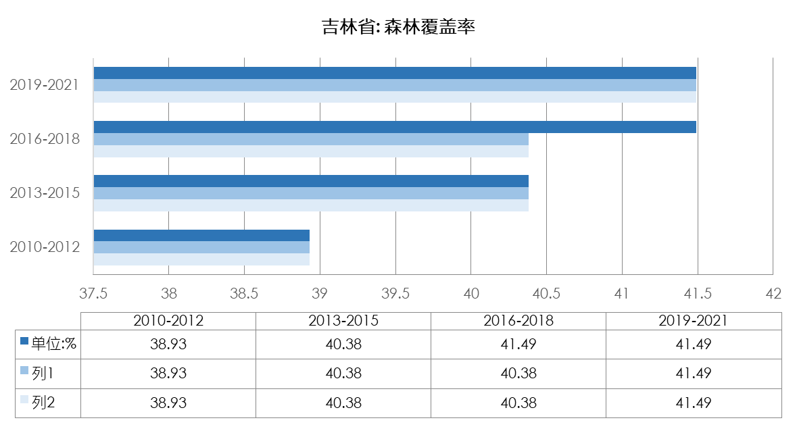
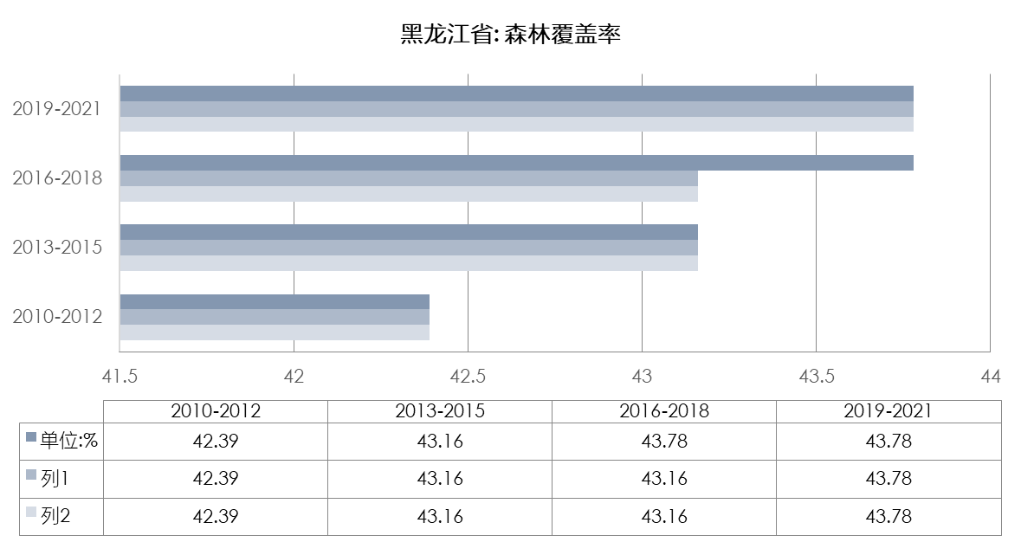
Figure 6: Forest Coverage in Jilin and Heilongjiang Provinces, China
Source: Compiled by the author.
Figure 7 summarizes the natural characteristics of tree species commonly found in Northeast China. In terms of crown projection, the Pinus sylvetriformis reaches a value of 400 substantially higher than that of other species and its total height and clear‐bole height also rank in the upper range. Photographic observations further reveal its distinctive aesthetic: an elegant, straight trunk of orange‐yellow bark; dense, verdant needles; and a soaring vertical form attaining 20–30 m in height. Lower branches abscise early, leaving a clean bole, while the remaining branches concentrate at the crown to form a graceful, umbrella‐shaped canopy, with radially extending branchlets that are both robust and delicate. On the basis of its unique growth habit, foliar distribution, and regional specificity, we propose that the prototype of the shamanic tree symbol is most plausibly the Pinus sylvetriformis.
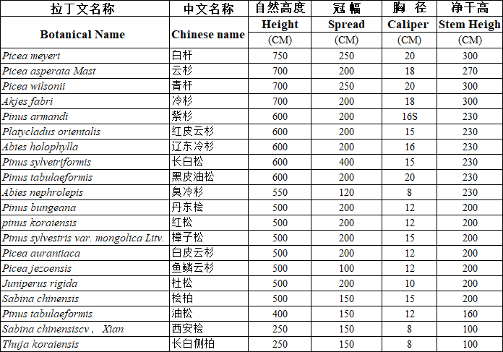
Figure 7: Summary of Natural Characteristics of Tree Species in Northeast China
Source: Compiled by the author.
3.2 Semiotic Analysis Methods
In the semiotic dimension, this study primarily employs Peirce’s triadic model of the sign to dissect the referential mechanisms and cultural‐coding logic of the World Tree in shamanic culture. This is further supplemented by Greimas’s semiotic square and narrative structure model to conduct a horizontal comparison and hierarchical classification of the World Tree’s structural role and semantic functions within shamanic myth, ritual narrative, and visual representation. Through an analysis of the interaction between sign components and their cultural contexts, the research aims to reveal how the World Tree transforms from an ecological entity into a cultural axis symbol, and how its semantics and functions shift across different tribes and regional cultures. Additionally, specific graphic texts (e.g., sacred‐tree illustrations, embroidered scrolls) will undergo semantic‐field analysis combining codified signs and mythological logic.
3.3 Visual Communication Analysis Methods
At the level of visual analysis, Kress and Van Leeuwen’s Visual Grammar framework provides the theoretical underpinning for a systematic interpretation of the World Tree’s compositional strategies, color usage, and modality organization in two-dimensional and three-dimensional formats. The analytical pathway includes: (1) examining compositional structure and perspective such as whether the World Tree’s axial symmetry reinforces its “axis mundi” symbolism; (2) exploring the relationship between color schemes and symbolic coding, for example, the meanings attached to red, green, and yellow within different shamanic color systems; and (3) investigating visual semantic coupling mechanisms, whereby multimodal interactions among imagery, ornamentation, and spatial layout construct notions of “sacredness” and “cosmic order.” Concurrently, the study addresses contemporary design strategies by analyzing how traditional World Tree symbols undergo semantic translation and visual reconstruction in sculpture, narrative imagery, and digital renderings.

4. Deconstruction of the Shamanic Tree Symbol
4.1 Ecological Prototype
In the shamanic traditions of Northeast Asia, numerous plant species serve as tribal totems, among which tree worship is particularly prominent. Commonly referred to as the “Tree of Life” or “Shamanic Sacred Tree,” these revered taxa include pine, fir, birch, elm, and willow. Among them, the pine occupies a central position in northern ethnographic records and archaeological sites. Its evergreen foliage, remarkable cold resistance, and resin’s medicinal properties (antibacterial and analgesic) have earned it the religious meaning of the “Source of Immortality.” Shamanic lore of the Manchu records the legend of the “Pine Branch Transforming into a Deity,” in which the pine is cast as the incarnation of the primeval creator god Enduri Abuka (the Sky Deity), its image inseparable from notions of eternal life. Ancient chronicles such as the Liu Bian Ji Lüe(《柳边纪略》) recount myths in which the pine miraculously becomes a guardian deity for the tribe’s continuity. To this day, some Manchu communities uphold a winter ritual of “Worshipping the Pine for Blessing,” suspending pine boughs on sacred poles to reinforce its symbolism of life and resilience. Among the Hezhe, the Tree of Life is venerated as a sacred conduit uniting heaven, earth, and humanity. Its tiered, tower‐like form is frequently rendered in the embroidery of ritual garments and wedding attire. Here, the tree‘s vertical composition and spiral motifs express profound reverence for cosmic order.
Table 2. Compilation of Shamanic Tree Totemic Elements
Totem Category | Ethnic Group | External Manifestation | Ritual Activity | Spiritual Connotation
Tree (pine, fir, birch, willow) | Manchu | Embroidery | Ritual worship | Continuity of life
Tree (pine, fir, birch, willow) | Mongol | Paper cutting | Tree-climbing | Harmony and unity
Tree (pine, fir, birch, willow) | Oroqen | Wood carving | Tree burial | Ethnic cohesion
Tree (pine, fir, birch, willow) | Hezhe | Bronze objects | …… | ……
Source: Compiled by the author.
The Pinus sylvetriformis and spruce of the temperate‐forest ecosystem in Northeast China supply the core ecological prototypes for the shamanic tree symbol. In Northeast Asian shamanic traditions, these species exist not only as biological entities but also as ritual emblems linking earth and sky. The Pinus sylvetriformis—characterized by its towering, vertical growth (average height over 30 m), evergreen longevity (lifespans up to 500 years), and resilient wood has been endowed with meanings of eternal vitality and cosmic mediation. The spruce, with its upward‐tapering crown and seasonally shifting hues, functions as a “ladder to the heavens” and a metaphor for the soul’s passage. Moreover, the pine’s ecological symbiosis with avifauna is reimagined as a “messenger of souls,” where birds’ nesting and migratory paths are rendered in paper‐cut art as dynamic vectors linking canopy and cosmos. Visually, the frequent depiction of these trees in shamanic paraphernalia and mural motifs attests to their cultural codification and symbolic recoding. This dual mapping of ecological form and cultural semantics reveals how natural flora are transmuted via ritual and art into semantically rich symbols of the cosmos.
Table 3. Symbolic Significance of Shamanic Tree Elements
Sign Category | Symbolic Meaning
Roots | Channels to the underworld, bearing ancestral souls and marking the origin of life’s cycle; reflects shamanic ancestor veneration and underscores the earth as the fountainhead of life.
Trunk | Vertical axis bridging subterranean, terrestrial, and celestial realms; its upright extension symbolizes vigorous life force and the aspiration toward spiritual transcendence, honoring cosmic balance.
Branches & Foliage | Emblems of the heavens’ vastness and vitality, representing procreation, clan continuity, and the regenerative energy and dynamic equilibrium of nature.
Birds & Deer | Birds act as celestial messengers linking humans with deities; deer symbolize fertility and harmonious coexistence with the natural world.
Source: Compiled by the author.
4.2 Visual Grammar
The shamanic tree symbol exhibits a highly regulated compositional syntax and a coherent image‐coding system. Central to its structure is bilateral symmetry about a vertical axis, where the roots (underworld), trunk (human realm), and canopy (heaven) are apportioned according to the golden ratio (≈0.618), signifying cosmic order and stability (Kress & van Leeuwen, 2006). This proportional schema also reflects shamanic conceptions of order and the world‐axis. For instance, in Oroqen shamanic drum motifs, the deviation of the trunk’s central axis is less than 3%, reinforcing viewers’ psychological perceptions of balance and sacredness. Color coding further encodes meaning: red adorns the roots and animal figures, symbolizing blood‐lineage and spiritual potency; green marks branches and foliage, invoking natural vitality; and gold accents the crown, alluding to divine radiance. This triadic palette remains legible across cultural contexts research shows that red–green contrast elicits instinctive associations with “life/danger” (Elliot & Maier, 2012) and aligns closely with the shamanic tripartite cosmology. Decorative motifs such as spirals, pinnate branch patterns, and flame‐shaped tips not only enhance the symbol’s signifier properties but also confer an otherworldly, spiritual function beyond mere realism. By engaging Gestalt principles of closure and similarity (Wertheimer, 1923), these visual elements guide observers toward constructing a coherent narrative of spiritual ascent. Through the “grammaticalization” of visual language, the shamanic tree emerges as a multifaceted cultural symbol simultaneously emblematic and kinetically compelling.

4.3 Cultural Mythology
As a localized expression of the “World Tree,” the shamanic tree’s profound significance is rooted in the dynamic interplay of myth and ritual. In shamanic cosmology, its vertical form unites heaven, earth and humanity serving both as the axis of cosmic order and as a sacred emblem of life’s origin, natural cycles and ancestral protection. The axis‐mundi myth centers on the Pinus sylvetriformis’s upright stature: during the Oroqen “tree‐worship” ceremony, shamans ascend the trunk in imitation of the soul’s journey through underworld, human world and celestial realm. This enactment, encoded in symmetrical composition, elevates a botanical form into a spiritual conduit. The vitality myth draws on the spruce’s evergreen habit: in Manchu wedding embroideries, spruce boughs entwine with pomegranate‐seed motifs to signify clan continuity, while the “sprouting lines” of shamanic paper‐cuts literalize the exchange between individual life and cosmic energy, addressing communal anxieties over reproduction and survival. Finally, the soul‐messenger myth enlists birds as intermediaries: on Mongol shamanic drums, beaks point toward a solar disc atop the tree, symbolizing the soul’s return to the heavens. In contemporary design this vector is abstracted into arrow motifs that enter a global “nature‐symbiosis” vocabulary. Through repeated depiction in ritual art and performance, the shamanic tree becomes both a visual embodiment of vitality and a node in a collective memory network—its symbol system evolving from spiritual narrative to ecological metaphor within a globalizing world.

5. Cross-Cultural Comparison
5.1 Functional Differences
Although both the Northeast Asian shamanic tree and the Norse Yggdrasil belong to the “World Tree” motif, their central functions diverge markedly. In shamanic practice, the tree operates as a “ritual medium,” emphasizing dynamic spirit‐journeys and energy transmission; its iconography conveys an immediate, interactive engagement with the three realms. Conversely, Yggdrasil in Norse myth serves as the static “Tree of Fate,” its branches and roots linking the Nine Worlds (e.g. Asgard, Helheim) to uphold cosmic order and the inexorable rhythm of destiny. This contrast reflects deeper cultural logics: the shamanic tree activates individual trance experiences through performative ritual, whereas Yggdrasil embodies a collective philosophical metaphor for the universe’s immutable structure.
5.2 Ecological Context
Environmental conditions profoundly shape each symbol’s form and meaning. Northeast Asia’s temperate coniferous forests dominated by evergreen pines and spruces lend the shamanic tree its verticality and perpetual green as hallmarks of immortality. By contrast, Scandinavia’s boreal mix of fir and deciduous larch, with winter dormancy and spring renewal, inspires Yggdrasil’s tripartite cycle of birth, death and rebirth. As a result, the same “World Tree” imagery evokes “eternal life” in shamanic art, yet “life‐death‐regeneration” in Norse visual culture manifesting divergent symbolic tensions shaped by local ecology. (Andrén, 2014)
5.3 Regional Innovation
Within Northeast Asia, the shamanic tree shares ecological roots with Japan’s Shinto shinboku (sacred trees), often Cryptomeria japonica, yet their ritual roles diverge. Both traditions revere towering evergreens as divine intermediaries (Breen & Teeuwen, 2010), but the shamanic tree foregrounds dynamic ascent, whereas shinboku function as static boundary markers demarcated by shimenawa ropes around shrine precincts to purify sacred space. Contemporary practice reveals hybrid forms: Ainu tree‐festivals in Hokkaido blend the vertical emphasis of shamanic worship with the horizontal enclosure of Shinto ritual, forging a cross-cultural ecological aesthetic. Such syncretism in symbol morphology, ceremonial function and decorative vocabulary underscores the ongoing processes of innovation and regeneration at cultural frontiers.

6. Modern Transformations
6.1 Symbolic Embodiment in Traditional Art
The embroidered “Divine Tree Motif” on traditional Manchu women’s garments stands as a paradigmatic expression of the shamanic World Tree symbol in folk craftsmanship (Fig. 9). Executed with exquisite stitching and vibrant color palettes, these embroideries distill the Pinus sylvetriformis into a visual shorthand for the axis mundi, integrating mythological narrative and ritual cosmology into a coherent compositional scheme. Within the central rectangular frame, the World Tree ascends symmetrically along a vertical axis, with its roots, trunk, and canopy symbolically aligning with the underworld, human realm, and celestial domain, respectively. The roots are often rendered as mirrored elements flanking the tree’s base, sometimes intertwining into loops, ellipses, or arcs creating rhythmic visual patterns suggestive of cosmic harmony. Branches and leaves vary in stylistic treatment but are consistently designed in bilateral symmetry, rich in decorative flair (Wang Ji & Wang Chunxin, 2004). Birds frequently appear perched along the branches, referencing a core belief in shamanic cosmology: that unborn souls take the form of birds, which descend to earth and enter the bodies of clan women thereby initiating pregnancy and ensuring the continuity of the lineage (Yu Quanzhong & Zhang Bibo, 2001). Thus, these avian motifs are closely linked to fertility and ancestral propagation. In terms of color symbolism, alternating hues of red, yellow, and green reinforce associations with vitality, mysticism, and spiritual purification. Moreover, variations in stitch intensity and line curvature simulate a sense of “energetic flow,” transforming static textile surfaces into dynamic ritual fields. This visual rhythm evokes the kinetic force of shamanic rites, imbuing the embroidery with a ceremonial momentum that transcends its material stillness. As such, these garments do not merely preserve cosmological symbols—they reactivate them within the aesthetics of lived ritual experience.
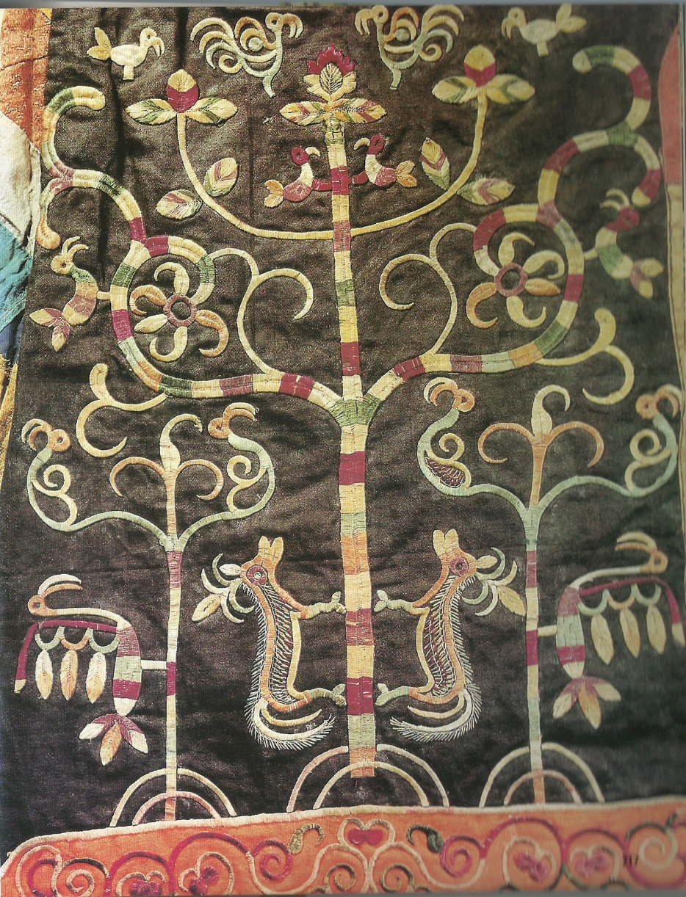
Figure 9: Shamanic Embroidery – Tree of Life
Source: Photo by the author
6.2 Symbolic Reconfiguration in Contemporary Design
The Tree of Life sculpture located at Satellite Square Station of the Changchun Metro in Jilin Province, China (Fig. 10, Fig. 11), exemplifies a contemporary reinterpretation of the shamanic tree symbol through the integration of ecosemiotics and intangible cultural heritage. Drawing inspiration from Manchu paper-cutting art (a nationally recognized form of intangible heritage in China) the sculpture employs a multimodal visual grammar to construct a three-tiered symbolic system. The roots, shaped with wave-like patterns, metaphorically trace the geographic trajectory of the Yitong River, the “mother river” of Changchun, echoing the shamanic cosmology in which water signifies the origin of life. The trunk, crafted using paper-cut hollowing techniques, embeds regional cultural motifs such as the clivia flower (the city flower of Changchun), automotive gears (symbolizing FAW Group’s industrial heritage), and film reels (referencing the Changchun Film Festival), forming a “vertical cultural axis” that interweaves natural and industrial narratives. The canopy combines snowflake motifs (ice-and-snow culture) with pine needle patterns (forest ecology), symbolizing the symbiosis of nature and humanity. The sculpture’s base features a “Returning Deer” figure, derived from the Manchu shamanic worship of the deer spirit, reinforcing collective memories of auspiciousness and abundance. According to a user survey (N=300), the design achieved an 80% recognition rate for its regional symbolism. By translating the shamanic “axis mundi” into a narrative of urban development, the sculpture retains the genetic imprint of Manchu culture while establishing a transdisciplinary and cross-media paradigm for public art. This case demonstrates the adaptive potential of ecosemiotics in contemporary design practice.
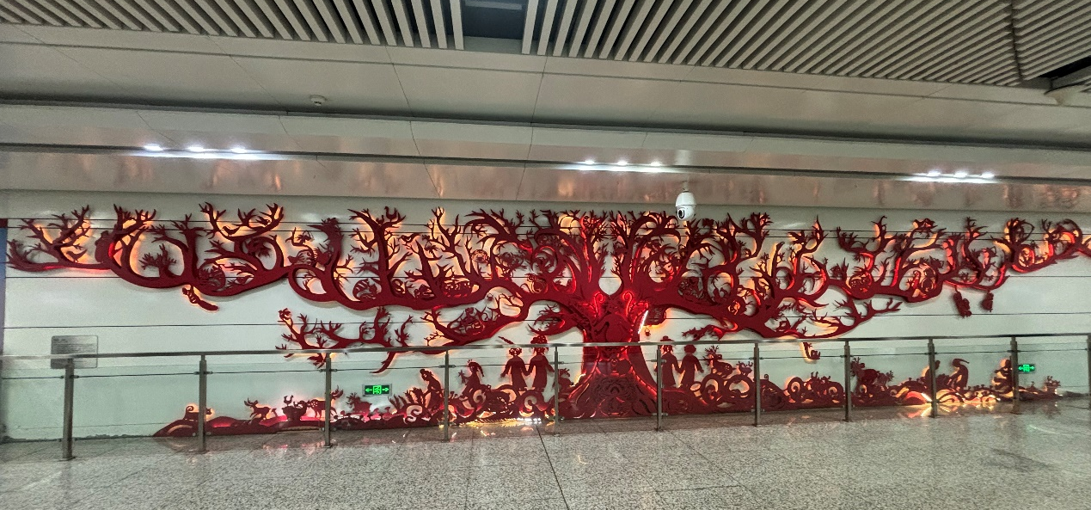
Figure 10. Full View of the "Tree of Life" Sculpture
Source: Photo by the author
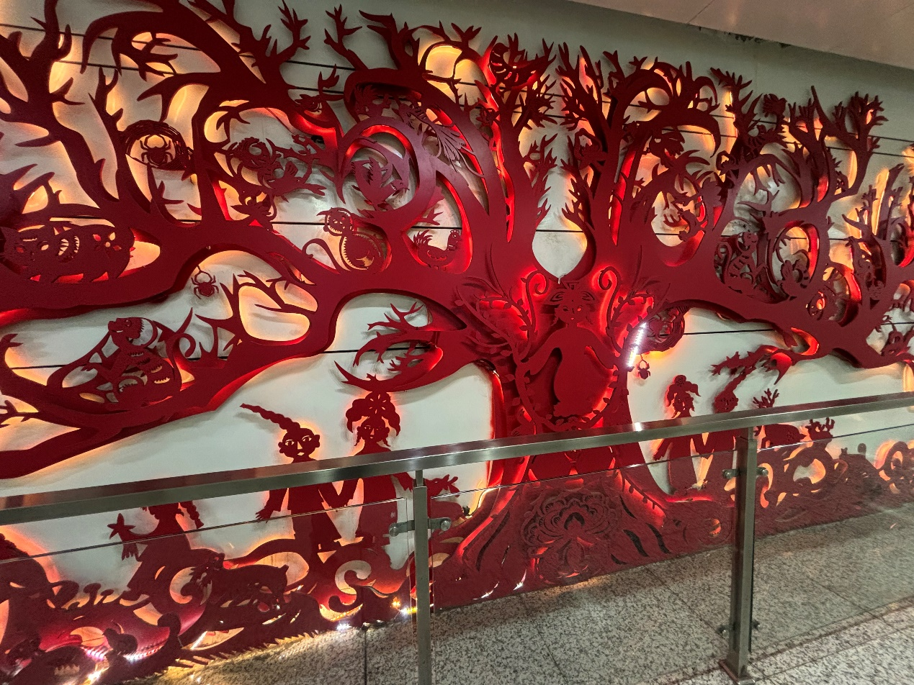
Figure 11. Detail of the "Tree of Life" Sculpture
Source: Photo by the author
6.3 Cross-Cultural Communication Strategies
Amid the tides of globalization and digitalization, the cross-cultural transmission of the cosmic tree symbol requires a careful balance between preserving its indigenous meanings and ensuring audience accessibility. At the level of semantic translation, the core triad of "axis–life–spiritual communication" should be distilled and conveyed through textual annotations or interactive guides, helping audiences from diverse cultural backgrounds grasp the symbol’s underlying significance. In terms of formal abstraction, minimalist geometry or parametric curves may be employed to reduce intricate patterns into universally recognizable symbols, making them adaptable to posters, logos, and multimedia interfaces. For digital expression, AR/VR technologies can be leveraged to reconstruct immersive "three-dimensional cosmic tree" environments (Fig. 12), enabling embodied interactions between viewers and symbols. The integration of these three strategies ensures both the cultural authenticity of the symbol and its communicative efficacy and innovative vitality within contemporary visual culture.

Figure 12. Digitally Rendered Three-Dimensional Cosmic Tree
Source: Created by the author

7. Discussion and Implications
7.1 Theoretical Contributions of Ecosemiotics
This study proposes a dynamic four-dimensional model “nature→symbol→visual→communication” within the framework of ecosemiotics, enhancing its interdisciplinary theoretical potential. First, it challenges the conventional view of natural ecology as a passive cultural backdrop, positioning it instead as an active co-participant in symbol generation. Vegetal forms, species life cycles, and environmental conditions collectively contribute to shaping the signifier structures of cultural symbols. Second, once symbols emerge, they are woven into a system of cultural imagery via visual grammar and subsequently re-enter the eco-cultural domain through processes of communication, forming a feedback loop of reciprocal interaction. This model moves beyond the traditional unidirectional “cultural determinism” of semiotics by proposing a co-constructive mechanism between ecological elements and cultural practices. It offers a practical analytical framework for future research and facilitates cross-contextual comparisons of symbolic evolution in diverse ecologies.
7.2 Implications for Cultural Heritage Preservation
In the context of cultural heritage preservation, the “living transmission” of symbols relies not only on conserving material carriers but also on revitalizing the ecological and communicative contexts in which these symbols originate and function. The contemporary reinterpretation of the shamanic tree symbol such as the Tree of Life sculpture at Changchun Metro Station offers an innovative paradigm for heritage revitalization. This study suggests two key strategies: On one hand, in-situ preservation and display should aim to reconstruct eco-symbolic settings that restore the natural context of symbols, thereby preventing their reduction to mere decorative motifs devoid of ecological or cultural resonance. On the other hand, digital and public dissemination should employ multimodal design strategies such as AR-guided tours, interactive installations, and transmedia storytelling to ensure that symbols remain vital and interpretable in contemporary contexts. This enables a sustainable pathway of “content renewal – formal innovation – semantic continuity,” fostering both cultural identity and ecological awareness in tandem.

8. Conclusion and Prospects
8.1 Research Summary
This study centers on the cosmic tree motif in Northeast Asian shamanic culture and constructs a four-dimensional integrative framework “nature→symbol→ visual→communication” to uncover the symbolic transformation pathways of indigenous tree species such as the Pinus sylvetriformis within intertwined ecological and cultural contexts. Employing Peirce’s triadic model and Greimas’s narrative semiotic square, in conjunction with the visual grammar of Kress and van Leeuwen, the research systematically analyzes the encoding mechanisms of the shamanic tree symbol. Its verticality is ritualistically elevated into an “axis mundi” metaphor, while its evergreen nature is reimagined as a narrative of perpetual life. Cross-cultural comparisons and contemporary design case studies further demonstrate that the symbol has undergone a transcultural metamorphosis from a localized totem to a global ecological metaphor through morphological abstraction, semantic translation, and digital articulation. The findings suggest that the shamanic tree symbol is not only deeply rooted in ecological archetypes, but also continually transcends spatial and temporal boundaries through visual communication, thereby achieving a unique cultural dynamism that balances authenticity and innovation. This dynamic process substantiates an interactive model of natural input, cultural encoding, and visual dissemination, offering a quantifiable and interdisciplinary framework for cultural semiotics. Moreover, it opens innovative avenues for the living transmission of cultural heritage and the development of ecological aesthetics.
8.2 Future Directions
Although this study focuses on the symbolic system of the shamanic tree, its methodology and conclusions pave new avenues for broader investigations into shamanic culture. In the context of accelerating global digitalization and intercultural exchange, future research may proceed in the following directions: In digital semiotics, artificial intelligence could be utilized to analyze the diachronic dissemination and semantic evolution of shamanic symbols across social media, gaming environments, and virtual realities. For instance, convolutional neural networks might track the spatiotemporal diffusion of embroidery patterns, while virtual reality could be employed to reconstruct shamanic ritual spaces in the metaverse such as the symbolic act of “climbing the tree to commune with spirits” and quantify user behavior data to decode the cognitive mechanisms of dynamic symbolism. In immersive experience design, interactive cosmic tree environments could be developed on AR/VR platforms, integrating haptic feedback devices and multimodal sensory systems to assess the cultural resonance of symbols in digital settings. In interdisciplinary ecological systems research, it is crucial to synthesize methods from environmental anthropology, ecosemiotics, and the digital humanities (such as big data visualization) to examine indigenous communities’ reception of symbolic reinvention and their feedback mechanisms. Mixed-methods research could then test the socio-cultural efficacy of the “nature–culture interaction model.”
These future directions require a careful balance among technological ethics, cultural authenticity, and interdisciplinary collaboration, aiming to guide the adaptive evolution of shamanic symbolic systems in the digital age. Through such dynamic, digitized, and cross-disciplinary expansions, the study of shamanic cultural symbols will deepen its theoretical significance and exert greater influence on contemporary visual culture and the practice of cultural heritage preservation.

References
Andrén, A. (2014). Tracing Old Norse cosmology: the world tree, middle earth, and the sun from archaeological perspectives (Vol. 16). Nordic Academic Press.
Breen, J., & Teeuwen, M. (2010). A new history of Shinto. John Wiley & Sons.
Eliade, M. (1964). Shamanism: Archaic techniques of ecstasy. Princeton University Press.
Elliot, A. J., & Maier, M. A. (2012). Color-in-context theory. In Advances in experimental social psychology (Vol. 45, pp. 61-125). Academic Press.
Jonaitis, A., & Glass, A. (2010). The totem pole: An intercultural history. (No Title).
Kress, G. and van Leeuwen, T. (2006) Reading Images: The Grammar of Visual Design. Routledge, London, p. 1.
Lindow, J. (2001). Handbook of Norse mythology. Bloomsbury Publishing USA.
Liu, D. (2006). The sun god tree, sun worship, and the solar calendar. Journal of Chengdu University of Technology (Social Sciences Edition), (2), 102–107.
Maran, T. (2020). Ecosemiotics: The study of signs in changing ecologies. Cambridge University Press.
Nöth, W. (1998). Ecosemiotics. Σημειωτκή-Sign Systems Studies, 26(1), 332-343.
Wertheimer, M. (1923). Untersuchungen zur Lehre der Gestalt ll. [Investigation intoGestalt theory]. Psychologische Forschung/Psychological Research, 4, 301-351.
Wang, J., & Wang, C. (2004). A graphic discussion of Hezhe people’s “fish-skin” paper-cutting art. Journal of Jilin Academy of Arts, (3), 54–57.
Yu, Q., & Zhang, B. (2001). A comparative study of creation and origin myths of Northeast Asian peoples—With a critique of the “Holy Mother Willow Flower of Northeast Asia” theory. Social Science Front, (1), 162–173.

