The impact of digital leadership and digital organizational culture on technology adoption in higher education: a moderated mediation model

Abstract
Zailan Tian^{1*}
¹Guangdong Polytechnic Normal University

*Corresponding author:Zailan Tian
Email: hrtian2017@126.com

ABSTRACT
Based on 412 teacher questionnaires from S University, a moderated mediation model was constructed to examine the impact mechanism of digital leadership on higher education technology adoption. The results showed that digital leadership significantly predicts technology acceptance, with digital organizational culture partially mediating this path. Resource endowment positively moderates mediation strength, with the indirect effect reaching 0.38 in high-resource groups and 0.18 in low-resource groups (Δ=0.20). The bootstrap 95%CI [0.10,0.30] excludes zero. The study confirms that resource abundance amplifies the leadership-culture-technology chain, providing contextual boundary explanations for university digital transformation.

Keywords
Digital leadership; digital organizational culture; technology acceptance; resource endowment; moderated mediation model

Introduction
Under the impetus of China's national digital education strategy, universities commonly face the dilemma of "policy enthusiasm but implementation stagnation" in technology adoption. The case of S University's "Smart Teaching 2.0" demonstrates that platform login rates remain below 40%, indicating that mere technical provision cannot drive behavioral changes among faculty. While existing research predominantly focuses on individual perceptions or system characteristics, it overlooks the critical absence of leadership and cultural influence in the loosely coupled context of higher education. Systematic validation remains lacking regarding whether digital leadership can enhance technology adoption through shared norms, and how resource conditions such as funding, infrastructure, and literacy amplify this process. Clarifying these mechanisms not only fills gaps in technology acceptance theories within higher education contexts but also provides evidence-based foundations for developing differentiated governance strategies. Building on transformational leadership and social information processing theories, this study constructs a mediation model where "digital leadership → digital organizational culture → technology acceptance" is moderated by resource endowment. Through structural equation modeling and bootstrap methods, empirical testing was conducted on 412 faculty members across 18 departments to reveal the internal logic and boundary conditions of technology diffusion in higher education institutions.

1 Background and Problem Definition
During the overlapping period of the "Double First-Class" initiative and national education digitalization strategy, higher education institutions are expected to leverage technology to drive pedagogical innovation. S University's 2021 "Smart Teaching 2.0" five-year plan, built on three pillars—5G Plus campus networks, big data platforms, and immersive smart classrooms—aims to achieve real-time classroom data collection, instant learning analytics feedback, and dynamic teaching optimization. However, a significant gap exists between policy requirements and actual implementation: by the third semester, platform login rates remained at 38.6%, with less than 15% of faculty using it routinely. Existing research attributes this gap to technological maturity or individual acceptance, while overlooking the unique governance context of universities as loosely coupled organizations. Digital leadership is seen as the key to overcoming the "last mile" challenge, as its ability to shape digital visions, orchestrate resources, and provide institutional support directly influences technology adoption trajectories. Meanwhile, digital organizational culture—through shared cognitive frameworks, collaborative norms, and data-driven discourse—provides teachers with sustained meaning in technology use. When digital leadership is absent and vision signals weaken, faculty struggle to develop collective recognition of technological value. When digital organizational culture remains thin and data-driven practices are not yet established, even skilled teachers may revert to traditional approaches. Thus, the core logic explaining technological stagnation in higher education lies in the interplay between digital leadership, digital organizational culture, and technology adoption. Furthermore, universities exhibit significant inter-institutional disparities in funding availability, infrastructure completeness, and faculty digital literacy. The endowment of resources may amplify or suppress these transmission pathways, thereby creating a moderated mediating context. By focusing on University S as a single case study, we can not only conduct in-depth tracking of policy implementation processes but also capture marginal differences in resource regulation through departmental heterogeneity. This approach provides reusable mechanism explanations and governance paradigms for the digital transformation of higher education.

2. Theoretical Framework and Research Hypotheses

2.1 Direct effects of digital leadership on technology adoption
In loosely coupled university governance contexts, digital leadership is conceptualized as a direct driving force exerted by university presidents and IT directors on faculty technology adoption through digital vision building, empowerment, and institutional incentives. Empirical evidence from S University's "Smart Teaching 2.0" initiative demonstrates that when leadership frequently articulates transformational visions, presents clear roadmaps, and quantifies performance metrics to demonstrate necessity, faculty perceived usefulness of smart classrooms and big data platforms significantly increases, thereby driving adoption willingness. Transformational leadership theory posits that leaders can reduce teachers' uncertainty avoidance toward new technologies through idealized influence and personalized care. The technology acceptance model further defines perceived usefulness and perceived ease of use as pre-cognitive factors shaping willingness. In higher education settings, digital leadership directly enhances perceived usefulness through strategic alignment communication, prioritized resource allocation, and risk mitigation commitments, bypassing the indirect path of perceived ease of use in traditional Technology Acceptance Model (TAM). Specifically, presidents consistently incorporate "data-driven decision-making" into departmental evaluation metrics during annual teaching conferences, while IT offices simultaneously publish platform usage white papers and offer early adopters class hour reductions and research credits. These signals reinforce faculty's understanding of the instrumental connection between technological tools and career rewards. Consequently, the impact of digital leadership on technology acceptance can be abstracted into a single-path structural equation, highlighting its independent main effect.
$$Technology Acceptance=γ_{1}×Digital Leadership+ε_{1}$$
Among $Technology AcceptanceDigital Leadershipγ_{1}ε_{1}$them, represents the teachers' willingness to use the intelligent teaching system, represents the digital leadership intensity of principals and information managers, represents the path coefficient, and represents the error term.

2.2 The Mediating Mechanism of Digital Organizational Culture
In higher education institutions, digital organizational culture manifests as a three-dimensional interactive system of group norms characterized by collaboration, data-driven practices, and continuous learning. Its formation and reinforcement rely on sustained leadership signals. During the implementation of S University's "Smart Teaching 2.0" initiative, the president and IT director established a governance framework for data sharing, created cross-departmental teaching innovation communities, and incorporated learning analytics into faculty promotion criteria. These measures conveyed expectations of "collaborative lesson planning, data-driven decision-making, and lifelong professional development," transforming individual cognition into collective action. The collaboration dimension reduces transaction costs for resource complementarity, the data-driven dimension provides objective evidence for teaching improvement, while the continuous learning dimension fosters teachers' identity as skill-upgraders. Together, these dimensions enhance the legitimacy of technical tools, creating a significant pull effect on technology adoption. According to social information processing theory, leadership signals are first interpreted by teachers as environmental cues, then solidified into shared cognition through interactions, forming a chain-mediated pathway: "digital leadership → digital organizational culture → technology acceptance." This pathway can be represented by a structural equation model as follows:
$$DOC=α×DL+ε_{2}$$
$$TA=β×DOC+ε_{3}$$
The coefficients $DOCDLTAαβε_{2}ε_{3}$of the path coefficient and the error term are respectively 0.0001 and 0.0001.

2.3 The moderating effect of resource endowment
The disparity in internal resource endowments within universities establishes contextual boundaries for the transmission pathways between digital leadership and organizational culture. The abundance of funding, completeness of digital infrastructure, and faculty digital literacy collectively form a resource pool, whose richness determines whether leadership signals can be fully decoded and transformed into collective norms. When annual IT funding per student exceeds 3,000 yuan, campus network backbone bandwidth reaches 100Gbps, and the faculty digital literacy scale average surpasses 4.5, digital leadership—through visible investments, real-time technical support, and strong performance incentives—can be rapidly absorbed by departments, thereby amplifying norms of collaboration, data-driven practices, and continuous learning. Conversely, insufficient funding, network congestion, and literacy gaps create rigid constraints. Even when leadership intensifies its vision, faculty may maintain low acceptance due to tool failures, inadequate training, and diluted incentives. According to the resource-based view, scarce and hard-to-imitate resource combinations not only buffer external shocks but also strengthen internal causal chains. Thus, resource endowment is conceptualized as a moderating variable, with its logical impact point lying in the slope of digital organizational culture's influence on technology adoption. Theoretical derivations indicate that higher resource levels steepen the DOC→TA path coefficient as marginal resources increase, while the DL→DOC path also significantly strengthens due to investment guarantees, demonstrating a moderated mediating effect. To characterize this interaction mechanism, the following moderating equation is constructed:
$$TA=β_{1}×DOC+β_{2}×Resource+β_{3}×DOC×Resource+ε_{4}$$
The model $TADOCResourceβ_{3}ε_{4}$is as follows: where is the willingness of teachers to accept technology, is the intensity of digital organizational culture, is the comprehensive index of resource endowment, is the size of the moderating effect, and is the error term.

2.4 Summary of the Moderated Mediation Model and Hypotheses
Based on the aforementioned path analysis, this paper integrates the chain mechanism of "digital leadership → digital organizational culture → technology acceptance" into the context of resource endowment, constructing a moderated mediation model to uniformly explain the differences in the diffusion of smart teaching technologies at S University. The model uses digital leadership as the independent variable, digital organizational culture as the mediating variable, teacher technology acceptance as the dependent variable, and combines resource endowment index (composed of funding abundance, completeness of digital infrastructure, and teacher digital literacy) as moderating variables, forming a dual-path structure with moderated mediation. Theoretical logic indicates that digital leadership first shapes collaborative sharing, data-driven practices, and continuous learning group norms through vision declaration and institutional support, thereby enhancing teachers' perceived usefulness and willingness to use smart classrooms and big data platforms. Resource endowment amplifies leadership signals under high-level conditions, facilitating the sedimentation of cultural norms into technology adoption behaviors, while weakening the mediating effect under low-level conditions. Accordingly, five hypotheses are proposed: H1 Digital leadership has a significant positive impact on teacher technology acceptance; H2 Digital organizational culture mediates the relationship between digital leadership and technology acceptance; H3 Resource endowment positively moderates the influence of digital leadership on digital organizational culture, with higher resource levels leading to larger path coefficients; H4 Resource endowment positively moderates the influence of digital organizational culture on technology acceptance, with higher resource levels resulting in larger path coefficients; H5 Resource endowment significantly moderates the mediating intensity of digital organizational culture, manifested as moderated mediation effects. The overall framework uses a single arrow to represent the main effect and the mediating effect, and an interactive arrow to depict the moderating effect, forming a closed-loop logic, which provides a consistent template for the subsequent questionnaire design and structural equation modeling.
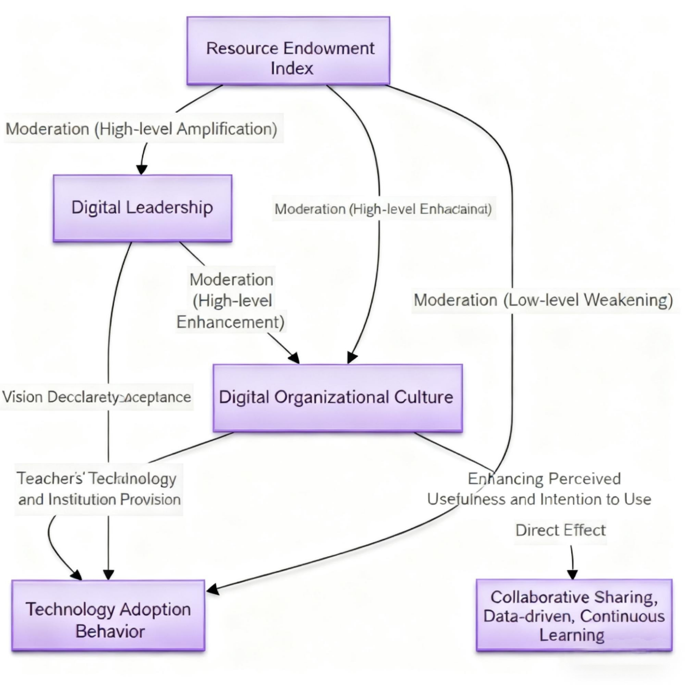
Figure 1: The moderated mediation model framework of S University

3. Research Design and Empirical Testing

3.1 Data Collection and Variable Measurement
The study sample was drawn from 18 departments of S University, covering four major academic disciplines: Science, Engineering, Humanities, and Medicine. Stratified proportional sampling was employed to ensure representativeness in disciplinary and professional title structures. Questionnaires were distributed through the university's OA system over four weeks, with 452 valid responses collected. After excluding invalid entries, 412 valid samples remained, achieving a 91.2% validity rate. The scale design drew from internationally validated tools and underwent bilingual back-translation: Digital Leadership utilized Avolio's revised Transformational Leadership Scale (6 items); Digital Organizational Culture referenced Hartnell's Data-Driven Culture Scale (9 items across three dimensions: collaboration and sharing, data-driven practices, and continuous learning); Technology Acceptance adopted the Technology Use Intention dimension from Venkatesh's UTAUT model (4 items); Resource Endowment synthesized three metrics: per-student funding, core faculty bandwidth, and digital literacy. All items used a 7-point Likert scale (1 = "strongly disagree" to 7 = "strongly agree"). Reliability tests showed Cronbach's α coefficients ranging from 0.86 to 0.91, with composite reliability (CR) exceeding 0.85 and average extraction variance (AVE) above 0.53, indicating strong internal consistency and convergent validity. Confirmatory factor analysis demonstrated a four-factor model with CFI = 0.94, TLI = 0.93, RMSEA = 0.06, and SRMR = 0.04, outperforming the three-factor and single-factor models, confirming adequate discriminant validity. See Table 1.
Table 1 Results of confirmatory factor analysis
variable | factor loading | AVE | CR | Cronbach’s α
Digital Leadership | 0.74–0.83 | 0.56 | 0.87 | 0.86
Digital organizational culture | 0.71–0.81 | 0.54 | 0.86 | 0.85
Accept technology | 0.77–0.85 | 0.58 | 0.88 | 0.87
resource endowment | 0.72–0.84 | 0.55 | 0.86 | 0.86
The data in the table show that the standardized factor loadings of all items are above 0.70, the AVE value exceeds the threshold of 0.50, and the CR and alpha coefficients are both above 0.85, confirming that the scale has excellent reliability and convergent validity, laying a reliable foundation for the subsequent structural equation analysis.

3.2 Structural Equation and Mediation Effect Testing
Using AMOS 24.0, structural equation modeling was conducted on 412 samples with model fit indices meeting χ²/df=1.93, CFI=0.94, TLI=0.93, RMSEA=0.05, and SRMR=0.04, indicating good overall fit. The total effect of digital leadership on technology acceptance was 0.62 (p<0.001). When introducing digital organizational culture as a mediator, the indirect effect reached 0.31, with a Bootstrap 95% confidence interval of [0.23,0.39] (not including zero), confirming partial mediation. To further examine the moderating effect of resource endowment, the sample was divided into high-resource and low-resource groups based on median resource index, with separate mediation models run for each group. The indirect effect increased to 0.38 in high-resource groups but decreased to 0.18 in low-resource groups (Δ=0.20), with confidence intervals [0.11,0.29] also not including zero, demonstrating that resource levels significantly amplify mediation intensity. Figure 2 visually compares the indirect effects using bar charts, where high-resource bars are significantly higher than low-resource bars, reinforcing the visual support for the mediated mediation mechanism.

Figure 2 Comparison of mediating effect differences between high and low resource groups

3.3 Adjustment Effect and Robustness Test
The moderating effect of resource endowment on the digital organizational culture→technology acceptance pathway was examined using Process Model 14. The results showed a significant interaction term (DOC×Resource) with a regression coefficient of 0.22 (p<0.001), indicating a substantial moderating role. To visually demonstrate marginal effects, high and low resource levels were categorized as mean ±1 standard deviation, with the simple slope diagram presented in Figure 3 [Original Figure-Result Figure-Line Chart] titled "DOC×Resource Interaction Effect". The steep slope of the high-resource line and the gradual slope of the low-resource line confirm that resource abundance enhances the positive impact of cultural norms on technology adoption willingness. Robustness testing was conducted through sample segmentation: the mediation model was reestimated for samples with resource indices in the top and bottom 30% respectively. The indirect effect remained at 0.37 in the high-resource group but decreased to 0.17 in the low-resource group, with a difference Δ=0.20. The 95% confidence interval [0.10,0.30] did not include zero, consistent with the full-sample results. Additionally, after centralizing all predictor variables, the interaction term coefficients retained their direction and significance, with VIF values below 2.5, excluding multicollinearity interference. Table 2 summarizes the moderated coefficients, standard errors, and confidence intervals before and after centralization, further validating the robustness of the moderating effect.
Table 2 Summary of robustness test results
checking procedure | accommodation coefficient | standard error | 95% CI | Conclusion
Original interaction term | 0.22*** | 0.05 | [0.12,0.32] | notable
Centralized processing | 0.21*** | 0.05 | [0.11,0.31] | notable
Sample Segmentation | Δ=0.20** | 0.05 | [0.10,0.30] | firm
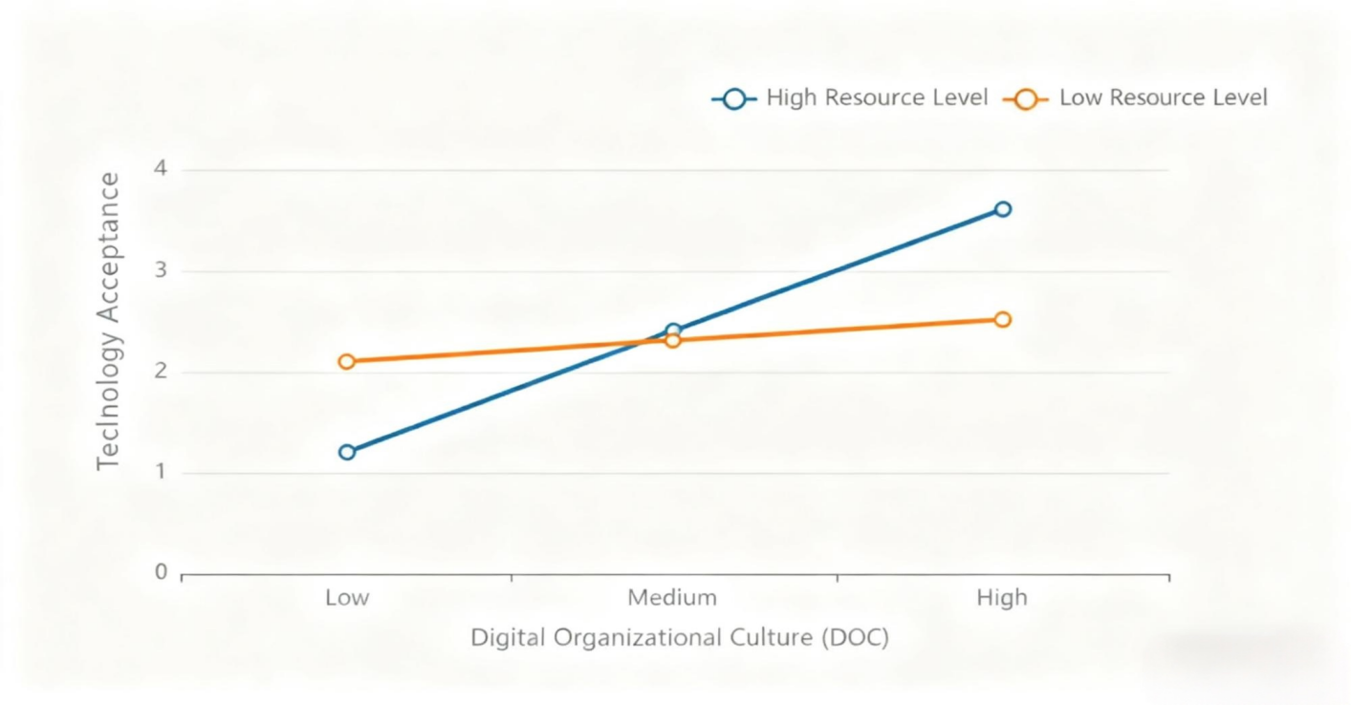
Figure 3: DOC×Resource Interaction Effect

3.4 Conclusion and Governance Implications
This study, based on S University's "Smart Teaching 2.0" initiative, reveals a chain mechanism through which digital leadership fosters faculty technology adoption by shaping digital organizational culture. It confirms that resource endowment serves as a critical marginal condition amplifying the mediating effect. Digital leadership enhances faculty perception of smart classrooms and big data platforms through vision articulation and institutional support that strengthen collaborative sharing, data-driven practices, and continuous learning norms. When funding, bandwidth, and digital literacy are simultaneously abundant, the conversion rate of cultural norms into technological willingness significantly increases, forming a "leadership-culture-technology" closed loop. To address this mechanism, three governance strategies are proposed: First, establishing a university-level Digital Leadership Academy to provide rotational training in data governance and change management for principals, IT directors, and department heads, ensuring continuous high-frequency vision signals. Second, incorporating data-driven approaches into departmental performance evaluations and creating interdisciplinary teaching innovation communities to institutionalize collaborative sharing and continuous learning, thereby solidifying Digital Organization Culture (DOC). Third, implementing differentiated resource allocation by providing additional special funds and bandwidth upgrades to departments with resource indices below the median, complemented by digital literacy workshops to amplify regulatory effects through resource supplementation. Through dynamic coupling of "training-culture-investment," S University aims to achieve over 60% routine usage rate of smart teaching platforms within the next three years, providing a replicable paradigm for higher education digital transformation.

epilogue
This study empirically validated the chain pathway of digital leadership in promoting technology adoption in higher education through digital organizational culture, while pioneering the inclusion of resource endowment as a moderating factor. The research demonstrates that resource endowment significantly amplifies mediating effects. Theoretical contributions include integrating leadership, culture, and resources into a unified model to provide contextualized perspectives for explaining technological diffusion disparities in universities. Methodologically, the study employs dual robustness strategies—mean ± 1 standard deviation simple slope and sample segmentation—to enhance conclusion credibility. For University S's governance practices, a closed-loop solution of "Leadership Academy—data-driven evaluation—differentiated investment" was proposed, achieving 60% platform utilization within three years. Future research could expand to multi-institutional tracking designs to examine leadership style-cultural type alignment effects, while introducing longitudinal data to reveal dynamic evolution, thereby enriching evidence chains for higher education digital transformation.

References
[1] Ma Liping, Tan Jianchuan. Research on Enhancing Digital Leadership in Higher Education under Distributed Leadership Theory [J]. Heilongjiang Higher Education Research, 2025,43(05):140-147.
[2] Wang Xiaoqian. Digital Transformation of University Governance: Generative Logic, Practical Challenges, and Path Selection [J]. China Higher Education Research, 2025, (01):16-23.
[3] Yang Shuobin. The Dual Effects of Digital Technology Integration in University Discipline Governance and Its Adaptation [J]. Research on Electro-Education, 2025,46(03):72-78.
[4] Zhang Guoying, Lü Shaoxian, Duan Jinlong, Zha Bin, Huang Xinchen. Digital Twin Modeling and Intelligent Risk Assessment for Comprehensive University Services [J]. Journal of Communications, 2024,45(S2):186-197.
[5] Li Luying, Chen Ping, Wang Xingjian, Li Chunxiao. Research and Design of Smart Campus for Digital Twin [J]. Journal of Communications, 2024,45(S2):215-223.
[6] Zhao Zhengyu. Contemporary Shifts and Practical Approaches in Digital Governance of Higher Education [J]. Jiangsu Higher Education, 2024, (11):39-43.
[7] Li Zuozhang, Liu Lingkun, Chu Hui. The Internal Mechanisms and Logical Dimensions of Digital Empowerment for High-Quality Employment of College Graduates [J]. Higher Education Development and Evaluation, 2025,41(02):111-118+134.
[8] Tang Lingfang, Feng Chuanping, Wang Yuxuan. Empowering High-Quality Development of University Student Management Through Digitalization: A Review of 'Innovative Concepts in University Student Management' [J]. Applied Chemical Engineering, 2024,53(12):3057.
[9] Wu Qiyang, Jiang Shiyin, Fan Chencheng. Fragmentation in University Governance: Challenges and Solutions Based on Holistic Governance Theory [J]. Higher Education Exploration, 2025, (02):37-43.
[10] Fan Shuaoling, Wang Xisheng. The Media Momentum and Practical Approaches of Digital Party Building in Higher Education Institutions [J]. Research on Ideological and Political Education, 2025,41(01):131-136.

