Strategic Resource Allocation for Sustainable Operation: A Machine Learning Approach for Chinese Enterprises Under Dual Economic Pressures
Shiying Zhang^{1,a}, Hui Wang^{2,b}, Yanhong Lu^{3,c}, Haoxin Xiu^{4,d,*}

¹Business School of Nankai University, Tianjin, 300071, Tianjin, China;
²Institute of Economics, Shandong Academy of Social Sciences, Jinan, 250002, Shandong, China
³School of Economics and Management, Hebei University of Technology,Tianjin, 300401 ,Tianjin,China
⁴Qingdao Hospital, University of Health and Rehabilitation Sciences（Qingdao Municipal Hospital), Qingdao, 266011, Shandong, China
ªEmail: shiying.zhang@mail.nankai.edu.cn
^{b}Email: ouc_wanghui@163.com
^{c}Email: luyanhong2015@163.com
^{d}Email: xhx19931011@163.com
*Corresponding Author

Abstract
Amidst concurrent internal and external economic pressures, Chinese firms confront a critical challenge: the allocation of scarce resources. This study addresses this dilemma by introducing a leverage point framework. Utilizing firm-level data, our approach employs interpretable machine learning. The goal is to algorithmically discern the pivotal drivers of corporate sustainability within a severely resource-constrained environment.
The empirical basis for our framework is a substantial dataset. It comprises 19,518 firm-year observations of Chinese A-share companies from 2010 to 2022. We deploy high-dimensional predictive models, specifically advanced ensemble algorithms like Random Forest and XGBoost. Sustainable operation is defined through two key metrics: the Sustainable Growth Rate (SGR) and Profit Volatility (PV). Following model construction, we examined feature importance and created Partial Dependence Plots (PDPs) to interpret the model, revealing key determinants and significant non-linear relationships.
The results offer compelling insights. Financial Performance and Green Development emerged as the highest-ranking determinants of corporate sustainability overall. Our modeling also uncovered critical non-linear thresholds. An optimal range for R&D investment was identified between a ratio of 0.125 and 0.20. Similarly, a supplier concentration level around 20% was found to maximize sustainable performance. Furthermore, the analysis exposed a variety of significant interaction effects, notably between the ROE growth rate and the adoption of green management practices.
This research significantly advances the understanding of corporate sustainability drivers. It presents a novel, interpretable, and data-driven framework for strategic resource allocation. This framework is particularly valuable for firms navigating competing demands during periods of economic strain. Ultimately, the study provides actionable, evidence-based guidance. This advice aims to ensure firms not only capture value generation but also cultivate the resilience necessary for long-term growth.
Keywords: Financial Performance, Green Development, R&D Investment, Supply Chain Management, Machine Learning

1 Introduction
Modern Chinese businesses are facing a collision of serious external and internal pressures that undermine their underlying operational viability and potential for long-term sustainability. Externally, geopolitical tensions have manifested as strategic technology embargoes related to access to important semiconductors, and imposition of tariffs on significant exports like new energy vehicles. Internally, the economy is dealing with the repercussions of a severe real estate slump. Collapsing builders, such as Evergrande Group, have created a domino effect for upstream construction suppliers in terms of capital flow, not to mention that downstream home buyers have properties that they likely will never get. This has tightened liquidity across the economy, with firms in every industry being forced to either reduce salaries or lay-off staff, exacerbating corporate instability in every sector and lack of resources.
In this “economic winter”, the businesses are in a strategic conundrum. On the one hand, firms must urgently restrict costs and remain focused on core activities for short-term survival and, on the other, national policy requires firms to make major forward-looking investments. The government's “dual carbon” targets are forcing firms to transition to green development and requiring significant capital expenditures for environmental protection and energy-saving initiatives. The ideological thrust for innovation-based growth from the strategic directions outlined in the 20th National Congress requires firms to commit substantial funds to R&D. These long-term implications are critical to developing national competitiveness and accountability for ecological well-being, yet firms may not have the financial means to support this longer-term focus.The most notable effect of this resource constraint is the broken capital chain and disrupted supply chain activities that make it extremely challenging for managers to finance green initiatives and R&D in addition to making sure they stay financially solvent and their supply chains resilient. Therefore, how to make the best use of severely constrained resources has become the biggest issue for corporate viability and sustainable development.
Existing literature on resource constraints has some valuable suggestions to offer. For example, it is found that firms following a ‘balanced’ strategy, allocating constrained resources to functions like marketing and R&D, perform better than firms allocating in only one function [1]. Another body of literature suggests that resource constraints can paradoxically spur innovation because firms must think creatively and make good use of resource constraints [2]. However, much of this literature has significant limitations in light of today's complicated crisis. First, the studies tend to lack multi-dimensional analyses examining the role of the constraints on a single domain, say innovation, without consideration of the fact that green development, supply chain management and financial health are all now connected. Second, the type of analytical models used are often linear models which examine how investments, say in R&D, affect financial performance without consideration of the reciprocal and synergetic nature of these domains [3]. Scholarly literature, in general, does not allow for a unified framework of the relational, and at times conflicting, relationships among these three investment areas. This is important when thinking about the complexities faced in today's environment.
In order to move forward in a way that rejects the path of standard linear analysis, this study takes a machine learning (ML) approach. We have selected reasoning for a computational perspective because ML will allow for modelling of the complex, non-linear and bidirectional relationships that comprise corporate investment systems. Standard econometric approaches encounter endogeneity and multi-collinearity among variables and therefore routinely cannot model the multilayered complex interactions. Management uses simultaneous ML algorithms to simulate and forecast outcomes. Rather than limiting the analytical approach to cause and effect analysis pursued in traditional economics, the focus of the current research uses a whole-portfolio effect of a combination of investments that create the necessary green development, innovation and supply chain mix to achieve a baseline financial objectives as well as enable sustainable operation. ML model, by estimating prior data, identifies baseline variables and index points that would visually predict baselines of investments necessary to achieve baseline investments required in green development, ability for innovation and SCM to get the baseline of investment correct.
In the context of this research, we will draw upon a dataset of 16 indicators that investigate four main areas of the three focus areas (Green Development area GD, R&D Innovation area (RDI), Supply Chain Management area (SCM) and Financial Performance (FP) for firms in the manufacturing sector in China). In addition, the study will work to address the following principal and secondary questions: (1) What are the significant interconnected relationship and feedback loop mechanisms among investment in GD, RDI and SCM and their combined impact on FP? (2) What is the relative importance of Green Development, Research & Development Innovation and Supply Chain Management in regard to maintaining sustainable operation of an enterprise in extreme resource constrains? (3) Can we derive a foundational investment ratio of GD, R&D Innovation and SCM that will ultimately allow firms to achieve their baseline financial requirements while also providing a base for their green and innovation requirements?
The present study contributes to both theory and practice in significant ways. From a theoretical perspective, we will extend the literature on corporate strategy by offering a multidimensional, symbiotic relationship of investments that shifts thinking about conducting isolated or singular analyses to an exploratory systems analysis based on resource-based theory and principles of sustainable operation for an enterprise. From a practical perspective, we provide enterprise managers with a data-orientated, empirical framework for understanding and making crucial resource allocation decisions. The ability to receive predictive information about investment balances, allows this research to offer a practical path for Chinese enterprises not only to survive the current downturn in simultaneity, but also to build the grounds for long-term sustainable operation.

2 Theories and Literature review
This research explores the linkage of three established theories, Investment Decision Theory, the Resource-Based View (RBV), and the Going Concern Theory, to form a framework for corporate sustainable operation. In the published literature, investment decision theory, financial performance, green development, R&D innovation, and supply chain management have been covered in isolation. This research will bring these areas together to study how these areas contribute collectively and interdependently to enterprise sustainability, in the face of significant resource constraints.

2.1 Investment Decision Theory: From Unidirectional Dependent Links to a Systems View of the Process
Investment Decision Theory provides the underlying thinking regarding how resources unanimously link the decision to invest with the performance outcomes of the firm. Existing literature describes distinct but uni-modal relationships between financial investment and performance. For instance, it is known if you do a better job at investing you can create a form of increase in your corporate financial performance, especially when resource constraints exist [4], and the role of governance is also important [5]. Green investments are also better understood and lead to changes to the image of the company, and policy can act as a support for change [6]. R&D investment has been documented as a major driver of innovation and competitiveness [7]. The limitation of this literature is that there is no uni-modal framework regarding how those areas are linked back to each other. This paper extends investment decision theory, distinguishing not just financial investments, green investments, innovation investments and supply chain investments as investment activity, but the entire system as an investment opportunity. It lays the theoretical foundation for understanding how a portfolio of investments creates synergistic effects larger than the sum of its parts, which is the basis for going beyond the rational management of performance.

2.2. The Resource-Based View (RBV): From competitive advantage to an equilibrium horizon
The RBV theory indicates that a firm's internal configuration of special resources and capabilities is the primary driver of its performance. RBV is usually applied to describe how firms provide value under some market condition through using resources (i.e., capital, technology, reputation and brand name). RBV has been used to conceptualize green initiatives as a special strategic resource offering some competitive difference [8] and R&D as the mechanism for addressing and maintaining a technology differential [9]. This paper recasts the application of RBV. Instead of applying the framework of overcoming competitors as a goal, we are considering the internal problem of investing resources in the presence of scarcity. The main motivation is when considering the internal allocation of resources in the current economic setting, the focus is not on creating competitive advantage, it is on achieving dynamic equilibrium and synergy across a firms four core operational pillars; financial viability, environmental viability, innovativeness, and supply chain capabilities. This provides the theoretical rationale for investigating rational allocation of resources in building internal coherence and resiliency for progressively sustainable functionality.

2.3. The Going Concern Theory: The case for integrated management
The going concern assumption is a fundamental accounting assumption indicating an enterprise is a going concern for the indefinite future. It is the most rigorously defined explanation of our study, as it is the lowest rung on the ladder at which a sustainable operation is a requisite for survival. Getting the going concern status requires not just short-term profits, but persistently self-regulating the viability of the firm across multiple contingencies. The previous literature reviewed provides support for this framework, because stable operations are contingent on stable financial states [10], the long-term economic and social value of green development [11], the perpetual source of inspiration from R&D [12] and competencies in supply chain management [13]. The going concern theory captures the reinforcing nature of the contingencies. A major breakdown in one operation, like a supply chain breakdown, or a loss of innovativeness, can threaten the entire enterprise. In this way, Going Concern Theory formulated in this paper is a premise argument for integrated management. Long-term enterprise viability depends on moving beyond functional silos. This requires the strategic integration of financial, green, innovation, and supply chain activities. The objective is to build a resilient operational system with embedded strategic redundancy.

3. Research Design and Methodology

3.1. Rationale for Using Machine Learning
The purpose of this study is to predict sustainable operation within organizations through a model of the complex interrelationships between financial performance, green development, R&D and supply chain management. Traditional econometric methods are not suited to this analysis because of linear assumptions and endogeneity [14], which restrict predictive capability. Although econometric models are useful to describe the phenomenon, Machine Learning (ML) can provide an avenue for prediction that utilizes models specifically designed to identify complex non-linear patterns and interactions [15], which enhances predictive generalization beyond a given sample.
We employ a comparison of five ML models to measure the most predictive framework. This study employs a logistic regression baseline, a Decision Tree with no assumptions of linearity, and three advanced ensemble models, Random Forest, Gradient Boosting Regression Trees (GBRT) and XGBoost. The multi-model methodology allows for a comparison of model performance across operational complexity [16].
This approach ultimately enables a concurrent review from the superior predictive power of the ensemble methods to the interpretability of simpler models. This way we developed a robust, high-performing, understandable model framework for predicting corporate sustainability, while tackling the limitations faced by previous studies and offering a stronger lens for The Selection and Specification of Models.

3.2. Model Building and Variables
Our models utilize the predictive capacities of four operational dimensions considered relevant in the context of corporate sustainable development. The level of sustainable development is the dependent variable and is operationalized with two established indicators of the Sustainable Growth Rate (SGR) and Profit Volatility (PV).
To account for the contribution of each of the dimensions, we will produce five distinct models. The first is a Benchmark Model constructed with ten moderately general firm-level variables (e.g., size, age, leverage, state-owned). Then four subsequent topical models will be made by progressively adding some attributes of the set of predictive attributes:（1）Financial Performance Model (F): the attributes pertaining to profitability, cash flow and operational turnover.（2）Green Development Model (E): the attributes to do with green investments, environmental management systems, and green patenting.（3）R&D Investment Model (R): the aspects of R&D spending, R&D personnel and R&D outputs.（4）Supply Chain Management Model (S): the attributes related to supplier and customer concentration and asset turnover cycles. This allows us to then systematically assess the relative predictive power of each strategic dimension above and beyond the original firm attributes.

Table 1. Model construction
Variable to be predicted | Model | predictive variable
sustainable growth rate（SGR）  Volatility of earnings（PV） | Financial performance model（F） | GROE、GPF、GNFO、OT、LT
sustainable growth rate（SGR）  Volatility of earnings（PV） | Green development model (E) | greeninvest、greenmanagement、greentran、erse
sustainable growth rate（SGR）  Volatility of earnings（PV） | R&d investment model (R) | RDP、RDC、RDQ
sustainable growth rate（SGR）  Volatility of earnings（PV） | Supply chain management model (S) | CENSU、SUC、APT、ART
sustainable growth rate（SGR）  Volatility of earnings（PV） | Benchmark Model | SOE、Size、Lev、Board、Indep、Dual、TMTPay1、Mshare、Occupy、FirmAge
(Source: Own elaboration based on the main context of the paper).

3.3 Model Evaluating
This paper refers to the research methods of Uddin et al. (2022) and Ağbulut (2022)[17,18] and evaluates the model performance from two aspects: explanatory power and predictive error. The evaluation indicators include: in-sample fit $R_{is}^{2}$, out-of-sample fit $R_{oos}^{2}$, out-of-sample mean squared error MSEoos, and mean absolute error MAEoos. The definitions and calculation formulas of the evaluation indicators are detailed in Table 2.

Table 2. Evaluation indicators and calculation formula
evaluation indicators | Definition of indicators | computational formula
in-sample fit $R_{is}^{2}$ | In the training set, how well the predicted values of the model fit the actual observed values | $\frac{R_{is}^{2}}{R_{oos}^{2}}=1-\frac{\sum_{i=1}^{n}{{{(y}_{i}-\hat{y_{i}})}^{2}}}{\sum_{i=1}^{n}{{(y_{i}-\hat{y})}^{2}}}$ (1)
out-of-sample fit $R_{oos}^{2}$ | The degree to which the model predicted values fit the actual observed values in the test set
out-of-sample mean squared error MSEoos | The expected value of the squared difference between the out-of-sample predicted value and the actual value | MSEoos=1/n${\sum_{i=1}^{n}{{(y}_{i}-\hat{y_{i})}}}^{2}$ (2)
mean absolute error MAEoos | The expected value of the absolute value of the difference between the out-of-sample predicted value and the actual value | MAEoos=1/n$\sum_{i=1}^{n}{\left|y_{i}-{\hat{y_{1}}}^{2}\right| (3)}$
(Source: methods from Uddin et al. (2022) and Ağbulut (2022) ).

3.4 Model Explaining
Since the purpose of this study is not only to verify whether financial performance, green development, R&D investment, and supply chain management can predict the level of corporate sustainable development, but also to explore the differences in importance among different characteristics and how key characteristics predict the level of corporate sustainable development. Therefore, this paper follows the practices of existing studies and uses Relative Importance and Partial Dependence Plot to further explain the theoretical connotations behind the model.

3.4.1 Relative Importance to Compare Predictive Ability Differences Between Variables
To compare the differences in predictive ability among various characteristics, this paper uses the feature importance of the Random Forest for analysis. In the Random Forest, feature importance is usually calculated by measuring the contribution of features to the split in the tree. For each node split, the reduction in Gini impurity is calculated, then multiplied by the number of samples in the node, and finally accumulated across the entire tree or forest. The core calculation formula is:

$[∆I$(t)=I(t)-($\frac{N_{left}}{N_{t}}$ $×I(t_{left})$ + $\frac{N_{right}}{N_{t}}×I(t_{right}))]$ (4)

In Equation (4), Nt is the number of samples in node t; Nleft and Nright are the number of samples in the left and right child nodes, respectively. Then, the I(t)of each node is weighted by the number of samples in the node to obtain the total Gini reduction for each feature. Finally, these reductions are normalized to obtain the relative importance of each feature.

3.4.2 Partial dependence plots explain the predicted patterns and marginal impacts of key variables
To further explain how key characteristics predict the level of corporate digital transformation, this paper uses Partial Dependence Plot for in-depth analysis. The core calculation formula is:

fs(xs)=$E_{X_{C}}{[f(x}_{s},X_{c})]$ = $\int{f(x_{s}},X_{c})dP(X_{c})$ (5)

In Equation (5), fs is the response function for a given sample; s is the set of target features; c is the set of complementary features; Xs and Xc are the values of the features. The formula signifies the marginal impact on the prediction result given specific values of the features in Xc.

4 Data source and variable description

4.1 Data source
The study uses a sample from publicly listed Chinese A-share companies from 2010 to 2022, a timeframe of heightened globalization and digitalization, as well as increased focus on green development and corporate governance initiatives. Following standard screening procedures to ensure data quality and limit confounding effects, the original dataset was refined: (1) to remove firms with abnormal trading status; (2) to remove companies in the financial industry; (3) to remove observations missing the key variables; and (4) to remove outliers on the key variables in our study.
The final, unbalanced panel dataset, contains 19,518 firm-year observations, which cover 3,376 unique companies. We obtained the data primarily through the CSMAR and CNRDS databases, supplemented by the companies’ annual reports to check for accuracy. All primary continuous variables were Winsorized on the 1st (1%) and 99% percentiles to control for extreme values.

4.2 Variable Characteristics

4.2.1 Dependent Variables
As a way of characterizing the complexity behind corporate sustainable development, the study uses two dependent variables that are accessed through the CSMAR database. One of the dependent variables is Sustainable Growth Rate (SGR), which describes the growth rate that an organization could sustain without having to increase debt or equity. The other dependent variable is Profit Volatility (PV) which describes the degree to which the organization's earnings are stable and predictable. By taking a dual-indicator approach, it provides a richer understanding of corporate sustainable development useable, as opposed to a short-term pure financial metric alone, as it will provide meaning of the quality of growth and risk adaptive capacity. The integrated metric provides a long-term view of growth vs. risk-taking.

4.2.2 Independent Variables
The independent variables are grouped into four key dimensions, the indicators have been selected from literature.
(1)Financial Performance (F): To analyse financial performance and effectiveness of a firm, we are using the growth rate of Return on Equity (GROE), the growth rate of Operating Profit (GPF), the growth rate of Net Cash Flow from Operating Activities (GNFO), the Operating Cycle (OT), and the Turnover Ratio of Current Assets (LT)[19,20,21]. All of these variables reflect profitability and efficiency of operations along with effectiveness of management of assets.
(2)Green Development (E): The commitment of a firm to environmental sustainability is represented in the use of green investment in total assets (greeninvest), green management innovation (greenmanagement), green business model transition (greentran), and the environmental score from ESG ratings (esge) [22,23,24]. The term "green" includes direct investments, management systems, and overall environmental performance.
(3)R&D Investment (R): Innovation capacity will be assessed in this study by using the ratio of Research and Development expenditure to operating income (RDP), the presence of R&D alliances (RDC), and quality of innovation as defined by the breadth of knowledge in patents (RDQ) [25]. These three metrics encapsulate a firm's innovation processes intensity, co-creation, and output quality.
(4)Supply Chain Management (S): The parameters of the supply chain will be measured by supply chain concentration (CENSU), strategic cooperation alliances (SUC), the turnover rate of accounts payable (APT), and the turnover rate of accounts receivable (ART) [26,27,28]. These factors can provide information on the supply chain's structure, if third-party partnerships exist, and the efficiency of working capital.

4.2.3 Control Variables
In accordance with existing literature, the models control a set of core firm attributes: state ownership (SOE), firm size (Size), financial leverage (Lev), board size (Board), independent director ratio (Indep), CEO-chairman duality (Dual), top management compensation (TMTPay1), management ownership (Mshare), major shareholder expropriation (Occupy), and firm age (FirmAge). These account for differences in ownership structure, organizational scale, financial risk, governance structure, and life cycle stage.

4.3. Sample Division and Model Training
To honor the time-series nature of our data, we do not use conventional random-split validation since this can allow future information to be used to predict the past (data leakage). Instead we choose to use a moving horizon validation method, based on the work of CHEN et al. (2022)[29], which is not only appropriate for time-series analysis, but can also be seen as reliable and logically-based validation. Each test year (t) from 2010-2022 has a corresponding validation year (t-1) and training years (t-2, t-3).
To strengthen hyperparameter tuning, we will implement a cross-validation approach within the moving horizon time-series validation approach described above. For each fold of the validation data, we will create five folds. Then, we will train the model on the training data and 4 of the folds of validation data (not the fifth fold), and will evaluate on the fold where the model fit was not held to the training data. We can repeat the approach we just described to identify the best parameters for each of our models. Once we have identified the best parameter settings for each of our classifiers, our final, fitted models will be trained using the test data plus all of the validation data (the 5ths will be held-out), resulting in a suitable future prediction model. We have designed a rigorous, forward-looking process to eliminate look-ahead bias for evaluation of the predictive performance of particular models. A summary of the above process is illustrated at a high-level in Figure 1.

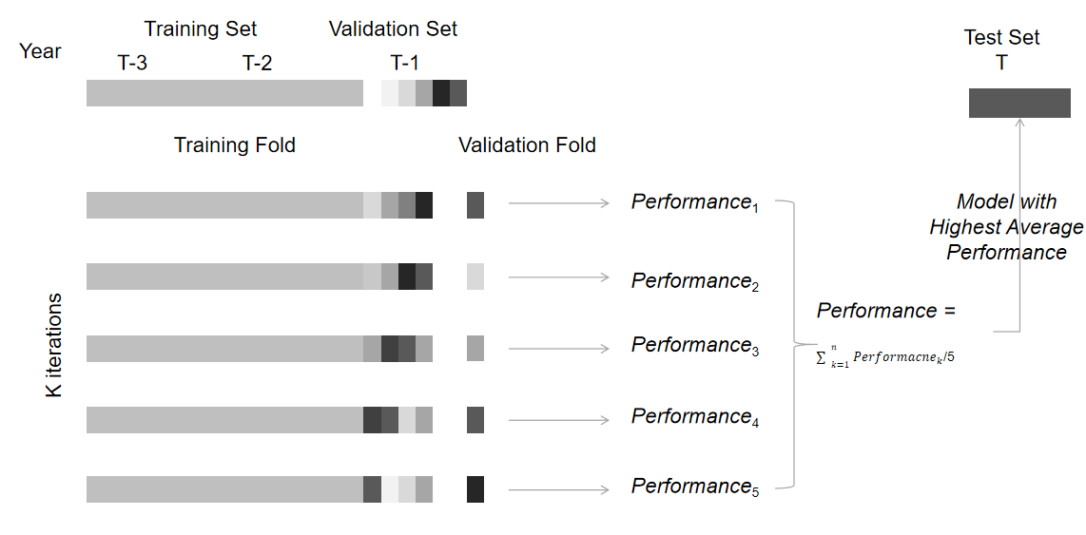
Figure 1. Sample division and model training

5 Analysis of empirical results

5.1 Descriptive Statistics
The statistical outcomes indicate that the mean, median, and standard deviation of the Sustainable Growth Rate (SGR) for companies are 0.047, 0.050, and 0.107, respectively. For Profit Volatility (PV), the mean, median, and standard deviation are 0.032, 0.018, and 0.044, respectively. The average proportion of green investments, along with their median and standard deviation, are 0.178, 0.147, and 0.132, respectively, suggesting a relatively small variance in the proportion of green investments among companies. The growth rate of Return on Equity (GROE) exhibits a significant disparity across different enterprises, with a mean, median, and standard deviation of -0.650, 0.000, and 9.516, respectively, indicating a wide distribution of this financial metric. The ratio of R&D expenditure to operating income (RDP) has a mean, median, and standard deviation of 0.047, 0.036, and 0.047, respectively. Supply chain concentration (CENSU) demonstrates considerable variation, with a mean, median, and standard deviation of 29.059, 26.740, and 15.759, respectively, yet remains within a reasonable distribution range.

Table 3. Descriptive statistical results
 | count | mean | sd | min | p50 | max
SGR | 19518 | 0.047 | 0.107 | -0.652 | 0.050 | 0.467
PV | 19518 | 0.032 | 0.044 | 0.001 | 0.018 | 0.366
greeninvest | 19518 | 0.178 | 0.132 | 0.016 | 0.147 | 0.953
greenmanagement | 19518 | 0.575 | 0.578 | 0.000 | 0.693 | 1.792
greentran | 19518 | 3.279 | 0.802 | 1.508 | 3.233 | 5.229
erse | 19518 | 12.801 | 13.412 | 0.000 | 8.169 | 74.191
GROE | 19518 | -0.650 | 9.516 | -132.208 | 0.000 | 36.367
GPF | 19518 | -0.273 | 6.002 | -68.104 | 0.000 | 49.028
GNFO | 19518 | 1.998 | 8.561 | -10.465 | 0.000 | 117.241
OT | 19518 | 0.963 | 2.469 | 0.000 | 0.339 | 46.639
LT | 19518 | 0.265 | 0.196 | 0.015 | 0.216 | 1.273
RDP | 19518 | 0.047 | 0.047 | 0.000 | 0.036 | 0.307
RDC | 19518 | 0.451 | 0.498 | 0.000 | 0.000 | 1.000
RDQ | 19518 | 0.318 | 0.271 | 0.000 | 0.389 | 0.896
CENSU | 19518 | 29.059 | 15.759 | 1.270 | 26.740 | 78.910
SUC | 19518 | 0.061 | 0.240 | 0.000 | 0.000 | 1.000
APT | 19518 | 1.433 | 1.860 | 0.000 | 0.953 | 16.699
ART | 19518 | 3.162 | 8.605 | 0.000 | 1.021 | 92.287
SOE | 19518 | 0.345 | 0.475 | 0.000 | 0.000 | 1.000
Size | 19518 | 22.330 | 1.310 | 19.790 | 22.113 | 26.832
Lev | 19518 | 0.427 | 0.200 | 0.033 | 0.421 | 0.944
Board | 19518 | 2.130 | 0.197 | 1.609 | 2.197 | 2.708
Indep | 19518 | 37.607 | 5.471 | 27.270 | 35.710 | 60.000
Dual | 19518 | 0.283 | 0.450 | 0.000 | 0.000 | 1.000
TMTPay1 | 19518 | 14.556 | 0.704 | 12.067 | 14.523 | 17.104
Mshare | 19518 | 13.840 | 19.390 | 0.000 | 1.070 | 70.381
Occupy | 19518 | 0.014 | 0.021 | 0.000 | 0.008 | 0.179
FirmAge | 19518 | 2.867 | 0.341 | 1.386 | 2.890 | 3.584
(Source: Own elaboration based on the main context of the paper).

5.2 Analysis of Model Fitting Effectiveness
The model fitting results are in Table 4 and clearly indicate a surprising strength in the predictive capacity of ensemble learning models. A Decision Tree on its own can achieve an exact fit (R²_is = 1.0000) in-sample, however its negative out-of-sample R² suggests that significant overfitting has occurred, making it an unreliable predictor. For ensemble models: GradientBoosting, XGBoost, and RandomForest-we also find much stronger generalization performance.
The more advanced models provide higher and more reliable out-of-sample R² and lower predictive errors (MSE_oos and MAE_oos) than both the linear regression and single decision tree. RandomForest, has especially robust and stable predictive capacity for predicting both of the two dependent variables, SGR and PV. Considering the RandomForest model had the highest overall accuracy and generalization ability overall, we will move forward with the RandomForest model for an analysis of feature importance and interpretation analysis.

Table 4. Comparison of model fitting effects
variable | Error  metric | LinearRegression | Decision Tree | GradientBoosting | XGBoost | RandomForest
SGR | R2_is | 0.1759 | 1.0000 | 0.4608 | 0.7752 | 0.9178
SGR | R2_oos | 0.1653 | -0.2036 | 0.4329 | 0.4231 | 0.4199
SGR | MSE_oos | 0.0089 | 0.0128 | 0.0060 | 0.0061 | 0.0062
SGR | MAE_oos | 0.0585 | 0.0712 | 0.0497 | 0.0516 | 0.0503
PV | R2_is | 0.1242 | 1.0000 | 0.2996 | 0.7447 | 0.8904
PV | R2_oos | 0.0907 | -1.0785 | 0.1536 | 0.0858 | 0.1544
PV | MSE_oos | 0.0015 | 0.0034 | 0.0014 | 0.0015 | 0.0014
PV | MAE_oos | 0.0247 | 0.0331 | 0.0231 | 0.0240 | 0.0237
(Source: Own elaboration based on the main context of the paper).

5.3 Feature Importance Comparison Analysis

5.3.1 Inter-group Importance Comparison
Relative feature importance described in Table 5, indicates different predictive hierarchies in SGR and PV. For both financial performance and R&D investment, the hierarchy of importance rankings are largely consistent across SGR and PV. The growth rate of ROE (GROE) and intensity of R&D expenditures (RDP) are absolutely most important predictors in both SGR and PV; indicating that monetary profitability and commitment to innovate with R&D are the decisive factors in their relative features.
The rankings for green development and environmental supply chain management diverge on the sustainability factor. Green transformation (greentran) is the most significant predictor for SGR and points towards a long-term structural change in a sector's growth trajectory. In contrast, green investment (greeninvest) is the most important sustainability factor for reducing profit volume volatility (suggesting the offer provides returns). In a similar way, supply chain concentration (CENSU) is most significant for SG_R reducing growth cost uncertainty, and managing accounts payable (APT) focuses on the profit's (PV) main driver, i.e., cash flow management to stabilize profits. These findings point to different strategic levers that need to be deployed to drive growth rather than simply a change to navigate or stabilize operation.

Table 5. Ranking of variable predictive importance
PanalA:Importance_SGR
Rank | financial performance | green development | R&D investment | supply chain management
1 | GROE | greentran | RDP | CENSU
2 | GPF | greeninvest | RDQ | ART
3 | LT | erse | RDC | APT
PanalB:Importance_PV
Rank | financial performance | green development | R&D investment | supply chain management
1 | GROE | greeninvest | RDP | APT
2 | GPF | greentran | RDQ | CENSU
3 | LT | erse | RDC | ART
(Source: Own elaboration based on the main context of the paper).

More generally, across both sustainability dimensions, Financial Performance and Green Development rank highest in their ability to influence sustainability, highlighting their central importance in building the long-term sustainability, viability, and stability of an enterprise.
In addition, this study uses the relative importance measure obtained in the random forest algorithm to express the differences in the predictive abilities of feature variables with respect to various elements of corporate sustainable development. In Figure 2 and Figure 3, we summarize the relative importance of each variable with respect to financial performance, green development, R&D innovation and supply chain management. The results indicate that GROE, GPF, greeninvest, greentran, RDP, LT and CENSU are the most predictive feature variables for corporate sustainable development, all of which are in the top 10 for relative importance. This suggests these characteristics are likely to be effective in moving corporate sustainability forward.
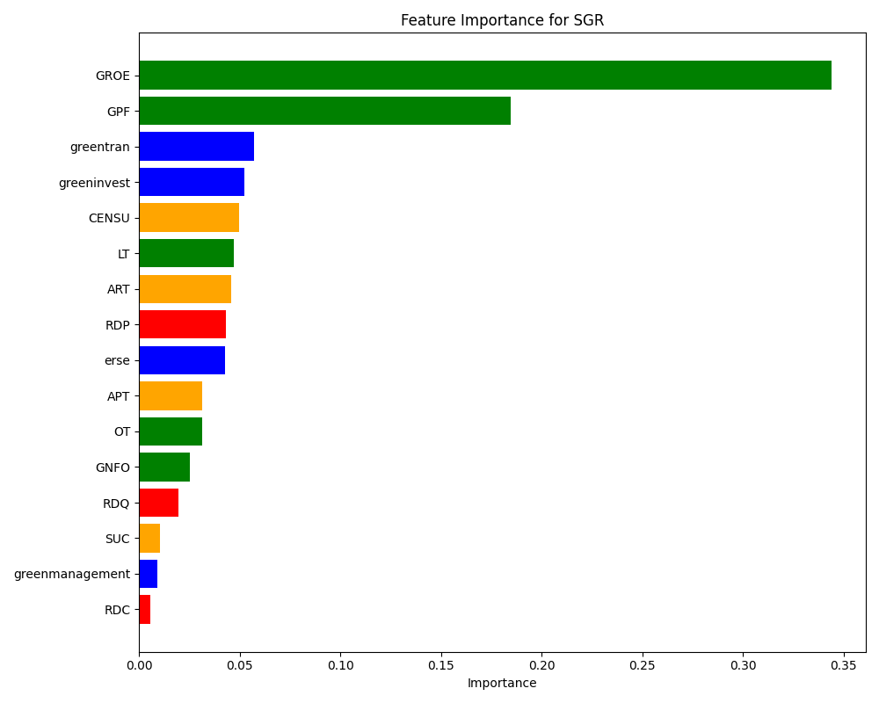
Figure 2. feature importance for SGR
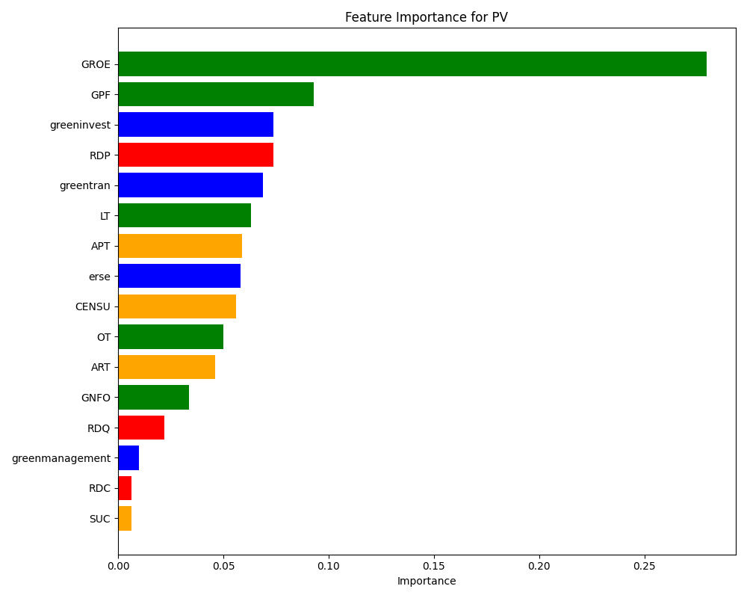
Figure 3. feature importance for PV

5.3.2 Univariate Importance Comparison
In addition, this study uses the relative importance measure obtained in the random forest algorithm to express the differences in the predictive abilities of feature variables with respect to various elements of corporate sustainable development. In Figure 4, we summarize the relative importance of each variable with respect to financial performance, green development, R&D innovation and supply chain management. The results indicate that GROE, GPF, greeninvest, greentran, RDP, LT and CENSU are the most predictive feature variables for corporate sustainable development all of which are in the top 10 for relative importance. This suggests these characteristics are likely to be effective in moving corporate sustainability forward.

Table 6. Univariate relative importance

Rank | Feature | Importance_SGR | Importance_PV | Total_Importance
1 | GROE | 0.3438 | 0.2793 | 0.6231
2 | GPF | 0.1844 | 0.0930 | 0.2775
3 | greeninvest | 0.0524 | 0.0738 | 0.1262
4 | greentran | 0.0572 | 0.0687 | 0.1258
5 | RDP | 0.0432 | 0.0737 | 0.1169
6 | LT | 0.0472 | 0.0633 | 0.1105
7 | CENSU | 0.0499 | 0.0559 | 0.1058
8 | erse | 0.0430 | 0.0583 | 0.1012
9 | ART | 0.0460 | 0.0462 | 0.0921
10 | APT | 0.0316 | 0.0591 | 0.0906
11 | OT | 0.0314 | 0.0501 | 0.0815
12 | GNFO | 0.0254 | 0.0336 | 0.0590
13 | RDQ | 0.0194 | 0.0220 | 0.0415
14 | greenmanagement | 0.0093 | 0.0101 | 0.0194
15 | SUC | 0.0104 | 0.0064 | 0.0168
16 | RDC | 0.0055 | 0.0065 | 0.0120
(Source: Own elaboration based on the main context of the paper).

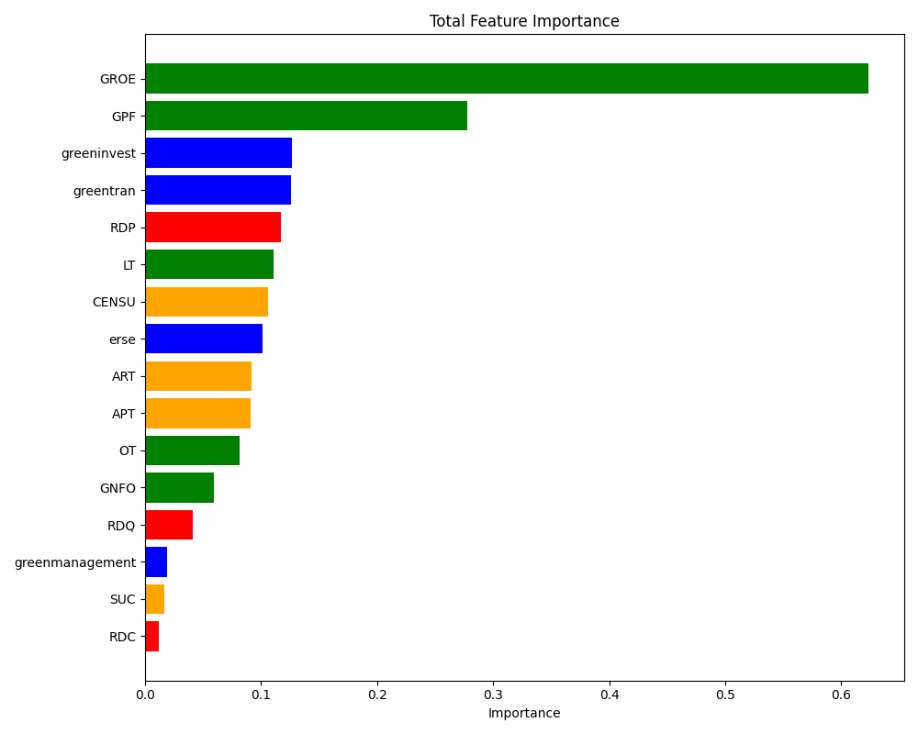
Figure 4. Total feature importance

5.3.3 Predictive Patterns of Key Feature Variables
1.GROE
Our results with Partial Dependence Plots (PDPs) show that higher GROE values are positively correlated with higher SGR and lower levels of PV，just as the literature suggests[30]. It is the combination of these relationships that leads firms to use a high GROE to strengthen their financial position, which allows them to use future corporate profits to fund their long-term sustainable growth without lenders' funding and enables them to better absorb shocks from market changes that potentially lower profits. Therefore, with this responsible approach to corporate profit allocation, this improves the predictability and sustainability of that individual firm and its industry.

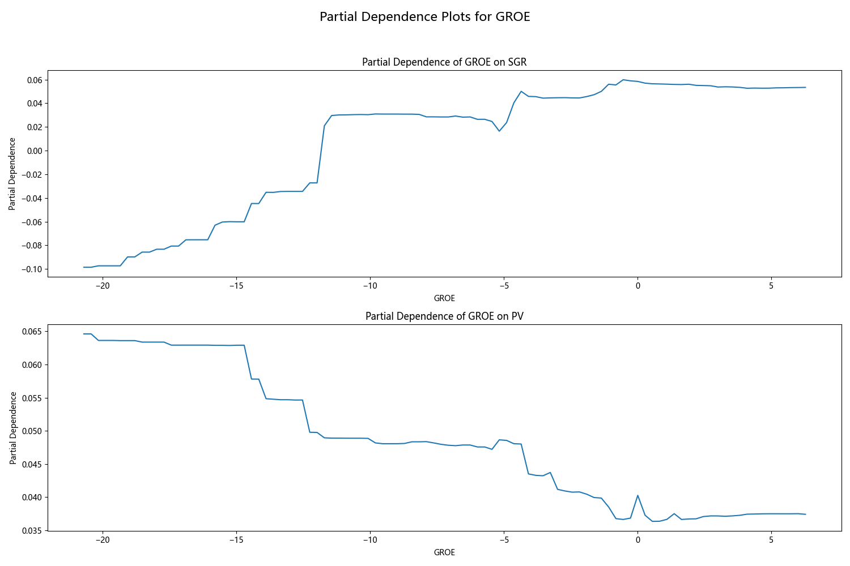
Figure 5. Partial Dependence Plots for GROE

2.GPF
As evidenced in Figure 6, GPF rapidly grows with SGR but decreases with PV. Both relationships are consistent with theory; profit growth is positive internal capital for reinvestment and growth, which leads to sustainable growth opportunities. Also, since profits are a buffer to the firm's finance, higher profits can improve firm resilience to shock the market; lower earnings variability leads to more sustainable operations that promote the sustainability of the firm.
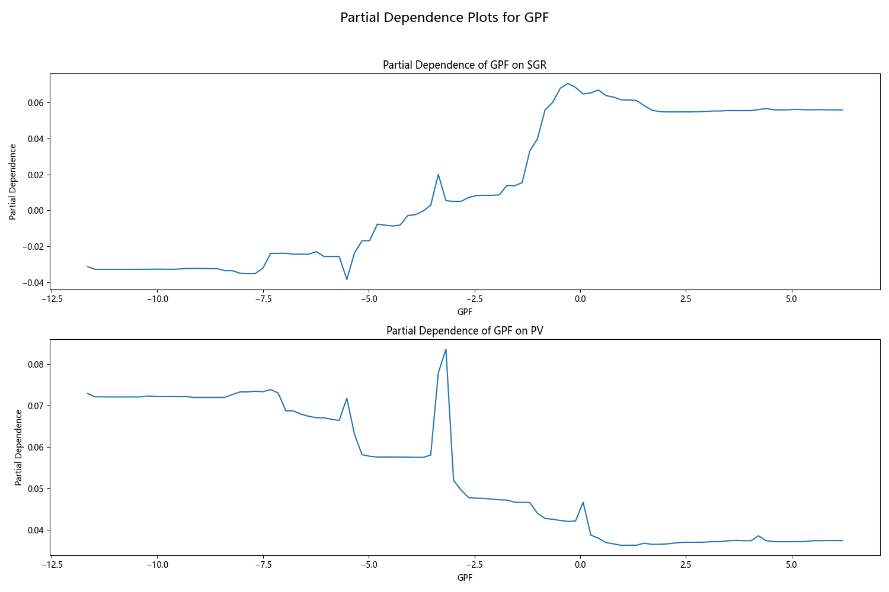
Figure 6. Partial Dependence Plots for GPF

3.greeninvest
Green Investment and the Interrelationship to Corporate Sustainability is complex and nonlinear. Increased green expenditures will temporarily decrease SGR and increase PV due to having short-term financial pressure. Our model to define this complex relationship indicated that the optimal ratio of green investment to total investment is approximately 0.20, to maximize SGR while minimizing PV. This highlights the challenges of calibrating corporate investments based on evidence-based competence to avoid the pitfalls of corporate over-investment.
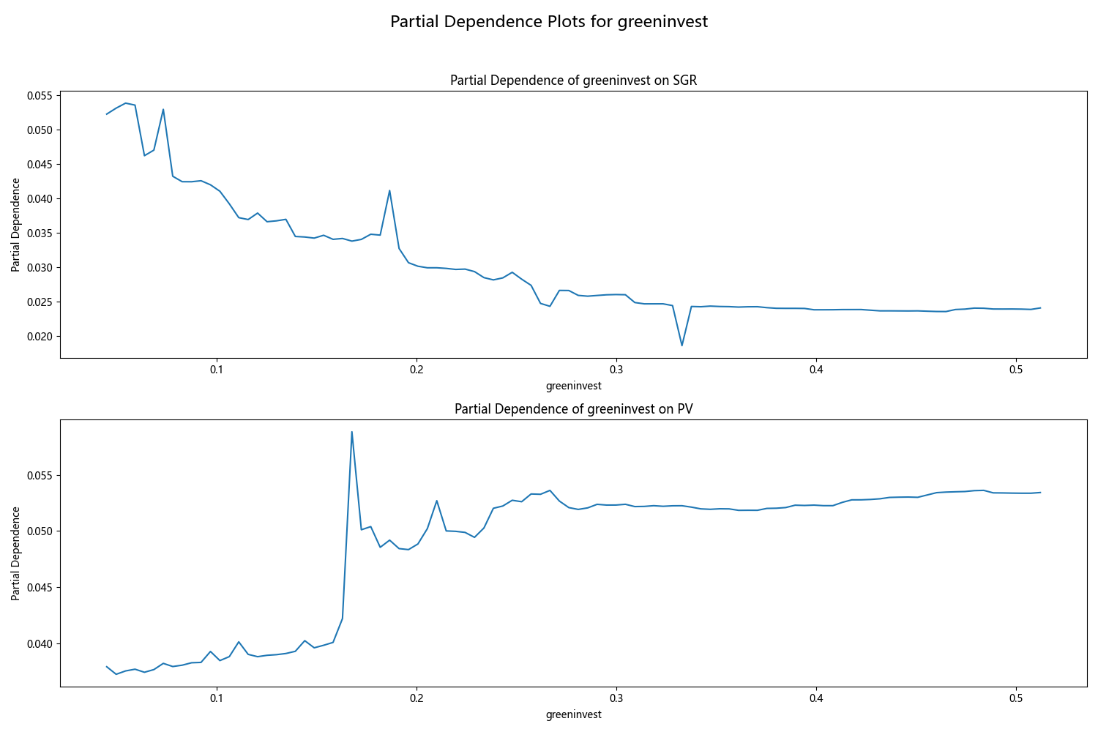
Figure 7. Partial Dependence Plots for greeninvest
4.greentran
Upon analysis of the greentran model, one can suggest the existence of a U-shaped relationship with SGR, in that it represents a recent decline in performance before progress is visible. While SGR declines, there is an overall upward trend in PV. An important inflection point is recognized for sustainable development at the greentran value of 3.5, which would give a potential for performance gains. While we see an industry average set at 3.279, firms can use this data point to target performance toward a benchmark that considers both an increase in sustainable involvement and realizing the often associated value for referring their ecological responsibility.
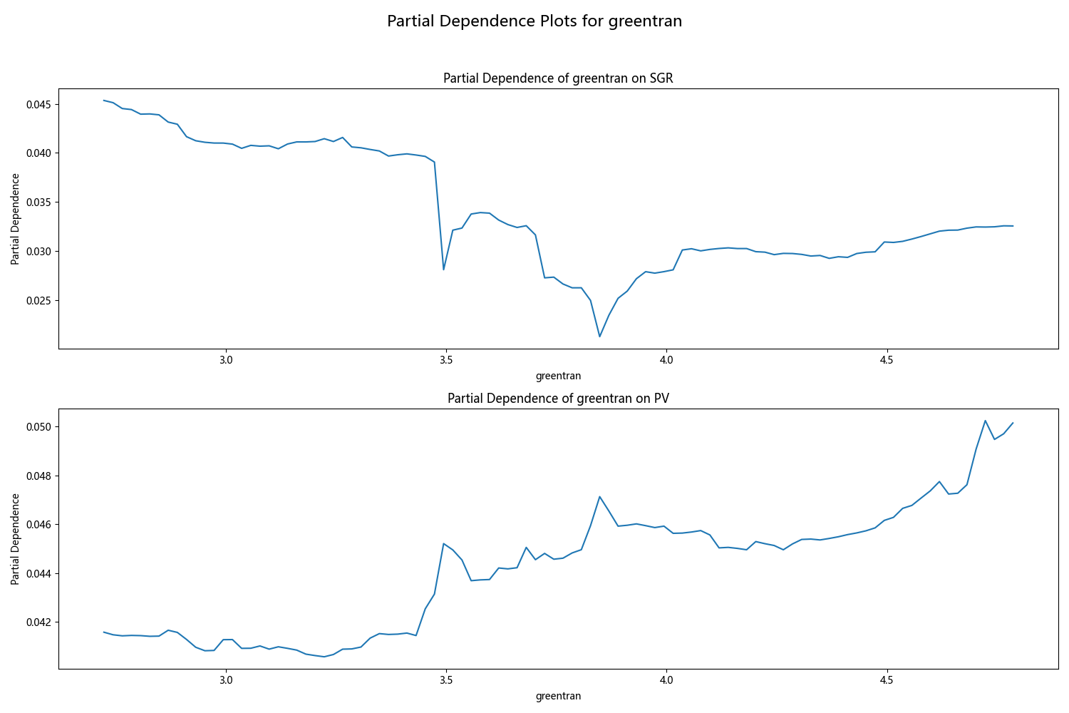
Figure 8. Partial Dependence Plots for greentran

5.RDP
Figure 9 displays the predictive model for RDP. The relationship with SGR was U-shaped, the relationship with PV has a clear positive trend. The analysis identifies an optimal RDP range of 0.125 to 0.200 to optimize for sustainable development, a much clearer benchmark than previous research [31]. The low industry mean RDP of 0.047 shows the need for firms to seriously ramp up their R&D commitment to attain that optimal performance level, and also to improve their sustainability.
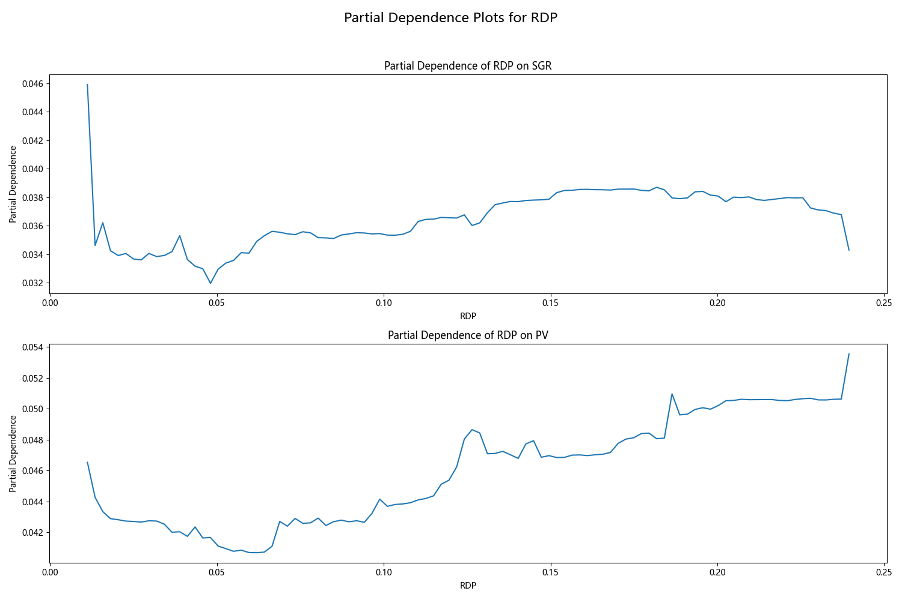
Figure 9. Partial Dependence Plots for RDP
6.LT
As demonstrated in Figure 10, the predictive model for RDP shows a U-shaped relationship with SGR, with positive trends with PV. The analysis shows that RDP is optimally transitioned in the range of 0.125 to 0.2 to maximise sustainable development, providing a finer yardstick than past research [32]. The low industry mean RDP of 0.047 illustrates the need for firms to dramatically increase their commitment to R&D investment to reach the optimum threshold for performance and sustainability.
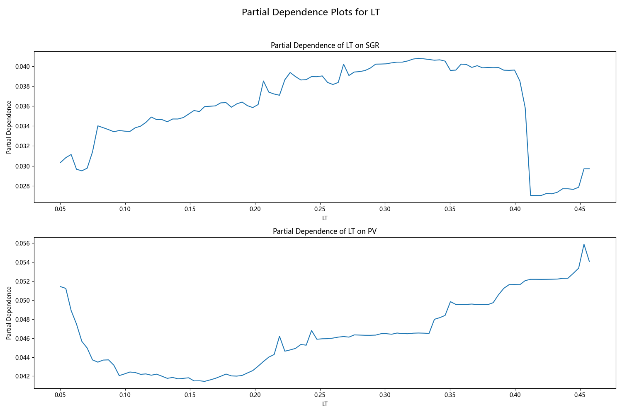
Figure 10. Partial Dependence Plots for LT
7.CENSU
Analysis reveals a non-linear, U-shaped relationship between CENSU and corporate sustainability. Our model identifies an optimal CENSU level of ~20% that maximizes SGR. While initial concentration leverages economies of scale, excessive levels increase strategic vulnerability and supply chain risk. This finding challenges prior linear assumptions, providing a data-driven threshold for managers. Firms must actively balance supplier concentration to mitigate dependency risks, balancing efficiency against strategic resilience to foster sustainable long-term growth.

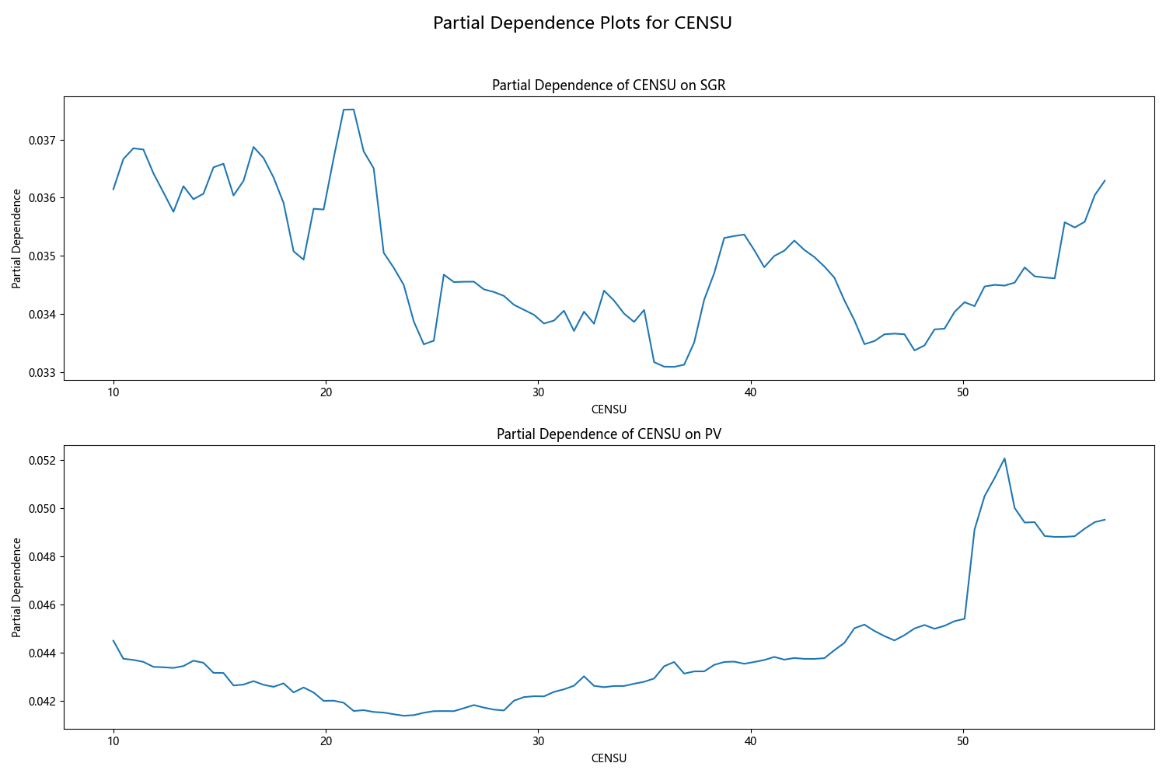
Figure 11. Partial Dependence Plots for CENSU

5.4 Interaction Effects
Table 7 shows the five pairs of interaction terms that were shown to be significant in predicting sustainable development outcomes. The "Global Contribution" was used to show the contribution of each pair of normalized interacted variables to the total variance in the prediction results. For example, if we consider the 1.10 percent value, it indicates that the interactive contribution from the Green Management and Research and Development Investment ratio (RDP) variable contributed 1.10 percent of the total variance. The five most prominent pairs of interacting variables are listed below.

5.4.1 Return on Equity Growth (GROE) and Green Development (greenmanagement)
Return on Equity (ROE) gauges the effectiveness of the organization at creating profits on behalf of the shareholders, while Green Management refers to the practices and strategic considerations with the intent of mitigating environmental impacts and considering sustainability. The strong interaction between the two identified themes indicates that if companies are able to “adopt and implement” green management practices into their operations system and processes, the profitability and financial performance of an organization will enhance, consequently enhancing their sustainable development. Green practices lead to cost savings, improved efficiency and enhanced brand reputation, and these factors can positively impact Return on Equity.

5.4.2 Profit Growth (GPF) and Green Management（greenmanagement）
Profit Growth is similarly an indication of an organization's ability to generate revenue while green management is an okay way to balance the impacts of economic growth and responsibilities related to environmental and social concerns. The robust association between the two suggests that organizations that pursue green initiatives are not inhibited from earning profits; in fact, green initiatives may enhance profitability by increasing the proportion of customers that prefer to deal with environmentally concerned organizations, promote resource efficiency by reducing costs, and mitigate liability relating to matters of environmental non-compliance.

5.4.3 Green Transformation (greentran) and Research and Development Quality (RDQ)
Green transformation refers to the process of moving towards environmental sustainability in business practices, while Research and Development Quality provides a measure of the innovation and effectiveness of R&D. The strong effect between the two indicates that high-quality R&D is needed in order for green transformation to be effective. Innovative R&D has real applications for the development of more environmentally sustainable technologies, products, and processes in support of sustainability commitments.

5.4.4 Green Investment Ratio (greeninvest) and Research and Development Investment Ratio (RDP)
Green investment, as defined in this study, refers to investment in environmentally sustainable projects, processes or initiatives; Research and Development Investment Ratio (RDP), refers to the investment of resources toward R&D. The strong interaction between the two variables suggests that organizations that focus on R&D are likely to invest in green initiatives. One explanation for this relationship is that organizations are aware that R&D is a necessity for the development and implementation of new green technologies, processes and products. In addition to generating R&D for new green initiatives, green investment will also produce new R&D since organizations will endeavor to improve their sustainable development performance.

5.4.5 Liquid Asset Turnover Ratio (LT) and Research and Development Ratio (RDP)
The Liquid Asset Turnover Ratio refers to how efficiently an organization turns its cash and other liquid assets into revenue; the Research and Development Investment Ratio (RDP) refers to the commitment to innovate. The strong interaction between LT and RDP suggests that the organization has committed to R&D - further sustainable development through the development of new technologies/processes - if the organization can turn its liquid assets into revenue efficiently. Efficient asset turnover would allow firms to have greater financial flexibility to be able to fund R&D projects that build upon the innovations that support environmental and social sustainable development.
The five strongest pairs of interacting variables highlighted in Table 7 which emphasized the contextual interaction between financial performance, green development and R&D investment which determined that by taking all of these metrics into account, organizations are likely to improve their sustainable development performance and ultimately achieve their sustainability orders.

Table 7. Interaction effects
Global Scores-SGR: | Global Scores-PV: | Predictor1 | Predictor2 | direction of interaction effect
5.78% | 7.38% | greeninvest | RDP | +
1.10% | 1.16% | greenmanagement | RDC | +
6.26% | 6.51% | greentran | RDQ | +
3.93% | 5.93% | erse | RDC | +
34.97% | 27.95% | GROE | greenmanagement | +
17.03% | 8.75% | GPF | greenmanagement | +
2.33% | 2.93% | GNFO | greeninvest | +
3.49% | 4.55% | OT | RDP | -
4.83% | 6.66% | LT | RDP | -
4.57% | 7.12% | RDP | greeninvest | +
0.65% | 0.73% | RDC | erse | +
1.72% | 2.26% | RDQ | greentran | +
4.42% | 6.46% | CENSU | RDC | -
1.49% | 0.67% | SUC | greentran | +
2.97% | 5.46% | APT | RDP | -
4.47% | 5.48% | ART | LT | +
(Source: Own elaboration based on the main context of the paper).

6 Conclusions and Implications

6.1 Research Conclusions
This study utilizes the data of Chinese A-share listed companies from 2010 to 2022 to construct a high-dimensional predictive model employing advanced machine learning ensemble algorithms. The purpose is to investigate predictive effects, specifically the extent to which financial performance, green development, investment in R&D, and supply chain management capacity can predict sustainable development level for enterprises. The findings suggest that multidimensional characteristics can predict sustainable development for corporations effectively; however, predictive effects varied considerably in magnitude.
Overall, the most influential factors are the growth rate of return on equity, profit growth rate, green investment ratio, green transformation, R&D investment ratio, current asset turnover rate, and supply chain concentration. The change of each capacity indicator under the specified rate of return on equity and green investment ratio was particularly effective at predicting sustainable development. There were significant differences in magnitude between the corporate characteristics, and relationships are ultimately complex and dynamic under different rates of return in each corporate category.
The findings also identified specific interaction effects as critical to support corporate sustainable development. Interaction effects with respect to sustainable development are shown, including: (1) the growth rate of return on equity and green management; (2) profit growth rate and green management; (3) green transformation and R&D quality; (4) green investment ratio and R&D investment ratio; and (5) current asset turnover rate and R&D investment ratio.
This paper makes a theoretical contribution by extending existing knowledge from an integrated view, incorporating prior literature from investment decision theory, resource-based theory, and sustainable operations theory as diverse domains with multidimensional corporate characteristics such as financial performance, green development, R&D innovation, and supply chain management. The newly proposed perspective offers a comprehensive analytical framework. The multidimensional perspective accounts for the limitations of singular perspectives presented in prior research, providing a more complete perspective and understanding of the complexities of corporate sustainable development. Analysing the interaction effects of multiple factors provides insight into the degree each factor affects the others, supporting corporate sustainable development. This analysis leads to a better understanding of the internal mechanisms around sustainable development while offering new insights to support future research.
The practical application value of this study includes developing a high-dimensional predictive model with tangible decision support tools for corporate management practice. This study will surface all possible influences for corporate management to account for regarding financial performance, green development capacity, R&D innovation, and supply chain management capacity when making the most informed investment decisions. This type of analysis will help enterprises recognize and optimize key drivers of development more accurately. The study takes action a step further by analysing the key influencing factors and variation of performance under various investment ratios. These analyses provide guidance to enterprises with respect to resource allocation, long-term strategy, etc., and thus better manage future planning in the market for sustainable development.
By integrating theoretical analysis and empirical research, this study links academic research to corporate management practice. The connection enhances an already comprehensive body of theoretical research while providing practical value for corporate managers. The research outcomes present a pathway with multiple modalities for enterprises to promote sustainable development representations through investment decisions, resources or allocation to corporate characteristics required to become sustainable. Many of the examples outlined are represented with rational deliberation and action significance, which presents direct guidance for organizational managers with respect to taking action in practice.

6.2 Limitations and Implications
While this report has contributed to our understanding of corporate sustainability, there are limitations to the conclusions that provide opportunities for further research. The primary limitation is the sample, which is limited to A-share listed companies in China between 2010 and 2022. The geographical and temporal limitations may also impact the extent to which the findings can generalize across different economic cycles and worldwide markets. Future research could explore research into this area with more international firms as well as longer time series data.
In addition, while the high-dimensional models in this report improve the precision of estimates, the black box nature of a high-dimensional model can make it difficult to derive practical implications from this case study. Future studies should evaluate how to refine the model (per the headers above), while also recognizing external dynamic factors such as macroeconomic changes as well as specific policy regulations to adapt to the model parameters. Finally, there are great opportunities for more research, including between -industry comparisons as well as a more exploratory study of the invisible interactions between green development, R&D spending and financial performance. By addressing the above areas, future research may be developed from this case study to better apply epistemology to adaptive practices that enterprises may use when pursuing sustainable development.

Author Contributions: Conceptualization, H.X. and S.Z.; methodology, S.Z. and H.X.; software, S.Z. and Y.L.; validation, S.Z. and H.X., H.W. and S.Z.; formal analysis, H.X.; investigation, S.Z. and Y.L.; resources, H.W.; data curation, S.Z. and Y.L.; writing—original draft preparation, H.X. and S.Z.; writing—review and editing, H.W.; visualization, H.W.; supervision, H.X. and S.Z. and Y.L.; project administration, H.W.; funding acquisition, H.X. , S.Z. and Y.L.. All authors have read and agreed to the published version of the manuscript.

Funding: The Youth Project of Shandong Provincial Natural Science Foundation "Theoretical and Practical Research on the Integration of Business and Finance in Public Hospitals from the Perspective of New Quality Productivity" (ZR2024QG200); The Youth Fund Project of Hebei Provincial Natural Science Foundation (G2024202011): Research on the Impact Mechanism of Key Core Technological Innovation from the Perspective of Multi-dimensional Dynamics of Internal Cooperation Networks in Enterprises; Science Research Project of Hebei Education Department（BJ2025277）and China Scholarship Council (202406200119).

Institutional Review Board Statement: Not applicable.

Informed Consent Statement: Not applicable.

Data Availability Statement: The dataset used in this study is available for download from the
Conﬂicts of Interest: The authors declare no conﬂicts of interest

Reference
- Lee, I.H.; Lévesque, M. Do resource-constrained early-stage firms balance their internal resources across business activities? If so, should they? J. Bus. Res. 2023, 159, 113410.
- Keupp, M.M.; Gassmann, O. Resource constraints as triggers of radical innovation: Longitudinal evidence from the manufacturing sector. Res. Policy 2013, 42, 1457-1468.
- Alam, A.; Uddin, M.; Yazdifar, H.; Shafique, S.; Lartey, T. R&D investment, firm performance and moderating role of system and safeguard: Evidence from emerging markets. J. Bus. Res. 2020, 106, 94-105.
- Chen, S.; Sun, Z.; Tang, S.; Wu, D. Government intervention and investment efficiency: Evidence from China. J. Corp. Financ. 2011, 17, 259-271.
- Mutlu, C.C.; Van Essen, M.; Peng, M.W.; Saleh, S.F.; Duran, P. Corporate governance in China: A meta‐analysis. J. Manag. Stud. 2018, 55, 943-979.
- Martin, P.R.; Moser, D.V. Managers’ green investment disclosures and investors’ reaction. J. Account. Econ. 2016, 61, 239-254.
- Yin, X.; Qi, L.; Ji, J.; Zhou, J. How does innovation spirit affect R&D investment and innovation performance? The moderating role of business environment. J. Innov. Knowl. 2023, 8, 100398.
- Makhloufi, L.; Laghouag, A.A.; Meirun, T.; Belaid, F. Impact of green entrepreneurship orientation on environmental performance: The natural resource‐based view and environmental policy perspective. Bus. Strategy Environ. 2022, 31, 425-444.
- Chen, X.; Chen, L.; Jiang, M.; Yan, J. Does R&D intensity promote the adoption of circular supply chain management? Evidence from China. Ind. Mark. Manag. 2021, 99, 153-166.
- Yu, Y.; Zhang, J.Z.; Cao, Y.; Kazancoglu, Y. Intelligent transformation of the manufacturing industry for Industry 4.0: Seizing financial benefits from supply chain relationship capital through enterprise green management. Technol. Forecast. Soc. Change 2021, 172, 120999.
- Hao, X.Y.; Chen, F.L.; Chen, Z.F. Does green innovation increase enterprise value? Bus. Strategy Environ. 2022, 31, 1232-1247.
- Zhang, J.; Chen, X.; Zhao, X. A perspective of government investment and enterprise innovation: Marketization of business environment. J. Bus. Res. 2023, 164, 113925.
- Fontoura, P.; Coelho, A. How to boost green innovation and performance through collaboration in the supply chain: Insights into a more sustainable economy. J. Clean. Prod. 2022, 359, 132005.
- Rocca, R.; Yarkoni, T. Putting psychology to the test: Rethinking model evaluation through benchmarking and prediction. Adv. Methods Pract. Psychol. Sci. 2021, 4, 25152459211026864.
- Pargent, F.; Schoedel, R.; Stachl, C. Best practices in supervised machine learning: A tutorial for psychologists. Adv. Methods Pract. Psychol. Sci. 2023, 6, 25152459231162559.
- Battiston, P.; Gamba, S.; Santoro, A. Machine learning and the optimization of prediction-based policies. Technol. Forecast. Soc. Change 2024, 199, 123080.
- Uddin, M.G.; Nash, S.; Diganta, M.T.M.; Rahman, A.; Olbert, A.I. Robust machine learning algorithms for predicting coastal water quality index. J. Environ. Manag. 2022, 321, 115923.
- Ağbulut, Ü. Forecasting of transportation-related energy demand and CO2 emissions in Turkey with different machine learning algorithms. Sustain. Prod. Consum. 2022, 29, 141-157.
- Patel, P.C.; João Guedes, M.; Pagano, M.S.; Olson, G.T. Industry profitability matters: The value of sustainable growth rate and distance from bankruptcy as enablers of venture survival. J. Bus. Res. 2020, 114, 80-92.
- Lee, M.T.; Raschke, R.L.; Krishen, A.S. Understanding ESG scores and firm performance: Are high-performing firms E, S, and G-balanced? Technol. Forecast. Soc. Change 2023, 195, 122779.
- An, S.B.; Yoon, K.C. The effects of changes in financial performance on value creation in digital transformation: a comparison with undigitalized firms. Sustainability 2023, 15, 2083.
- Zhang, Q.; Zheng, Y.; Kong, D. Local Environmental Governance Pressure, Executive's Working Experience and Enterprise Investment in Environmental Protection: A Quasi-natural Experiment Based on China's "Ambient Air Quality Standards 2012". Econ. Res. J. 2019, 54, 183-198.
- Zhao, X.Z.; Zeng, S.Y.; et al. Corporate Behavior and Competitiveness: Impact of Environmental Regulation on Chinese Firms. J. Clean. Prod. 2015, 86, 311-322.
- Jiménez-Preciado, A.L.; Martínez-García, M.Á.; Trejo-García, J.C.; et al. Short-and Long-Term Assessments of ESG Risk in Mexican Mortgage Institutions: Combining Expert Surveys, Radar Plot Visualization, and Cluster Analysis. Sustainability 2025, 17, 5616.
- Choi, J. Mitigating the Challenges of Partner Knowledge Diversity While Enhancing Research & Development (R&D) Alliance Performance: The Role of Alliance Governance Mechanisms. J. Prod. Innov. Manag. 2020, 37, 26-47.
- Shi, R.; Yin, Q.; Yuan, Y.; Lai, F.; Luo, X. The impact of supply chain transparency on financing offerings to firms: the moderating role of supply chain concentration. Int. J. Oper. Prod. Manag. 2024, ahead-of-print.
- He, Q.; Meadows, M.; Angwin, D.; Gomes, E.; Child, J. Strategic Alliance Research in the Era of Digital Transformation: Perspectives on Future Research. Br. J. Manag. 2020, 31, 589-617.
- Wang, Z.; Wang, Q.; Lai, Y.; Liang, C. Drivers and outcomes of supply chain finance adoption: An empirical investigation in China. Int. J. Prod. Econ. 2020, 220, 107453.
- Chen, X.; Cho, Y.H.T.; Dou, Y.; Lev, B. Predicting Future Earnings Changes Using Machine Learning and Detailed Financial Data. J. Account. Res. 2022, 60, 467-515.
- Rezaee, Z.; Tuo, L. Are the quantity and quality of sustainability disclosures associated with the innate and discretionary earnings quality? J. Bus. Ethics 2019, 155, 763-786.
- Chen, Z.; Liu, Z.; Suárez Serrato, J.C.; Xu, D.Y. Notching R&D investment with corporate income tax cuts in China. Am. Econ. Rev. 2021, 111, 2065-2100.
- Kajtazi, K.; Rexhepi, G.; Sharif, A.; Ozturk, I. Business model innovation and its impact on corporate sustainability. J. Bus. Res. 2023, 166, 114082.

Disclaimer/Publisher’s Note: The statements, opinions and data contained in all publications are solely those of the individual author(s) and contributor(s) and not of MDPI and/or the editor(s). MDPI and/or the editor(s) disclaim responsibility for any injury to people or property resulting from any ideas, methods, instructions or products referred to in the content.

